Easy pizza wrap recipe

Ingredients
- Tortilla wraps
- Tomato puree
- Cheese e.g. grated cheddar or mozzarella
- Chopped vegetables of your choice e.g. sweetcorn, onion, peppers
- Olive oil
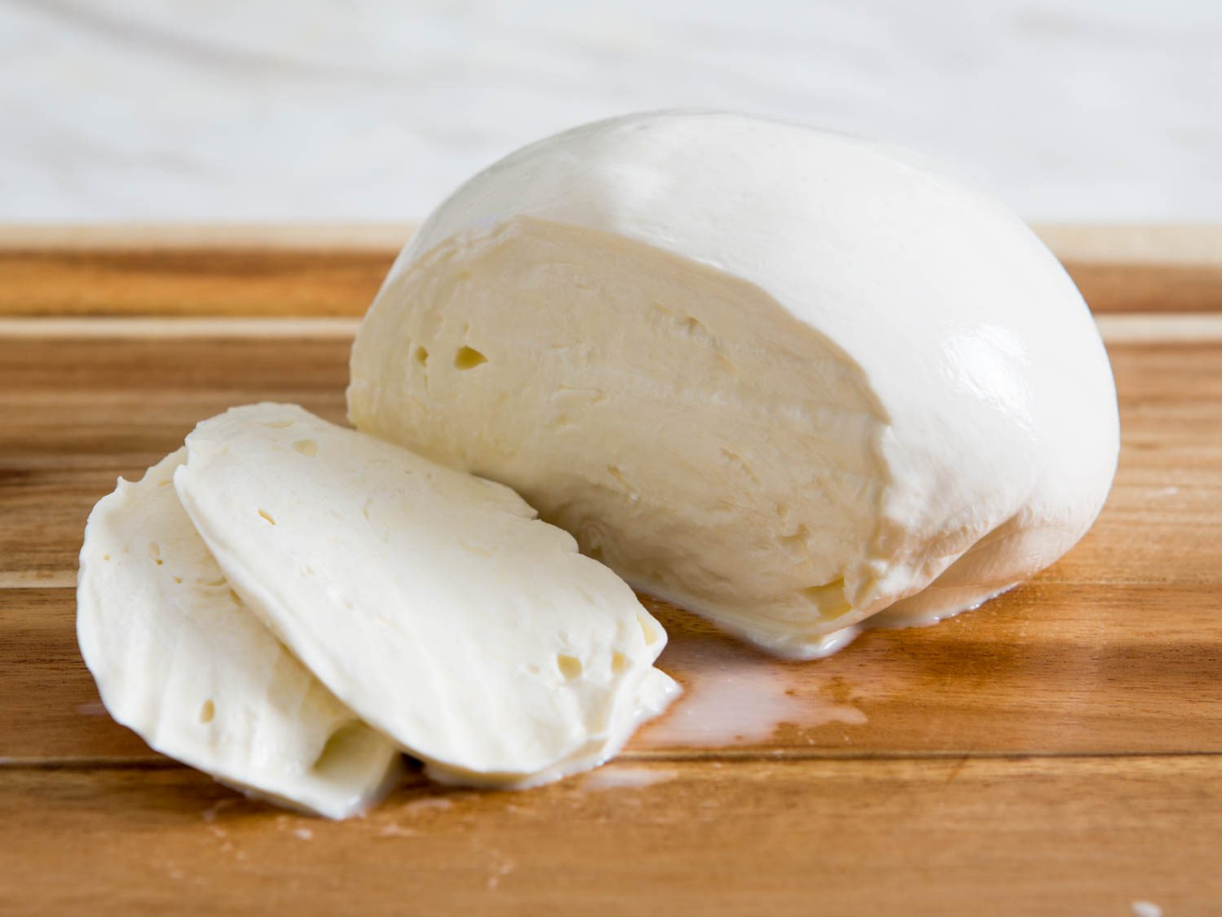

Equipment
- Baking tray
- Chopping board
- Knife
- Spoon
- Pastry brush
- Oven gloves

Next time, why not try adding cooked meat too?
Method
- With an adult, wash and dry your hands thoroughly and preheat your oven to 200 degrees.

- Using a pastry brush, coat your baking in a thin layer of olive oil (this is so your wrap doesn’t stick) and place the wrap on top. Then spread a little oil all over the wrap too.

- Then, squeeze some of the tomato puree in the middle of the wrap and spread it all over using a spoon, being careful to NOT go right to the edge so that you leave a crust for your pizza. You have now made a base ready for your toppings!

- With an adult, very carefully chop any vegetables you would like on your pizza using a knife and chopping board into small, bite size pieces and sprinkle them all over the wrap.

- Next, tear the mozzarella using your fingers and place it evenly onto your pizza, if you are using grated cheddar, you can simply sprinkle this evenly on top too.

- When you are happy with how your pizza looks, using oven gloves and adult supervision, carefully put the baking tray with your pizza on it in the oven for approximately 5-10 minutes, or until the cheese has melted and the pizza crust is golden brown.

- Finally, turn off the oven while your pizza cools for 2 minutes, then carefully cut into pieces and enjoy!

