Jobs you can offer to help with around the house

As we are all spending more time at home at the moment, now is a good time to practice helping out at home with household chores.

Below is a list of jobs you may like to help out with. If you are unsure how to do it, don’t be scared to ask for help, now is a good time to learn new skills!

1. Washing and drying the dishes after meal times.

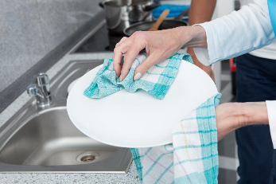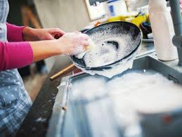

1. Baking or cooking a meal (with help) and remembering to clean up afterwards.

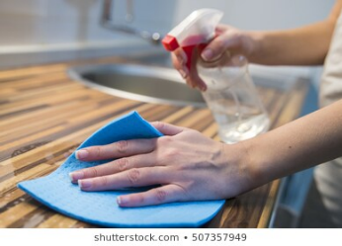

1. Helping to wash and clean the car.

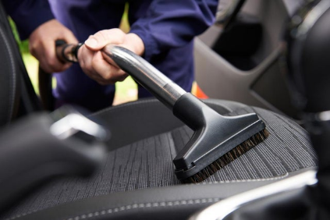

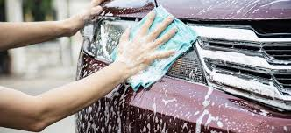

1. Stripping the bed and putting a clean duvet cover on.

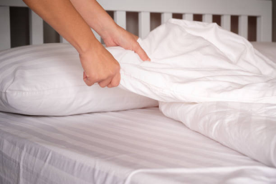

1. Help to feed, water and walk your pets if you have them.



1. Dusting and polishing the furniture.

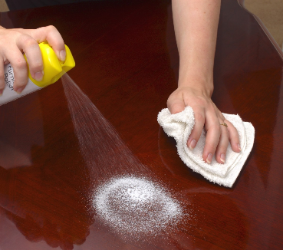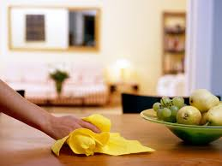

1. Hang out the washing on the line or on a clothes maiden.

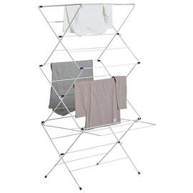

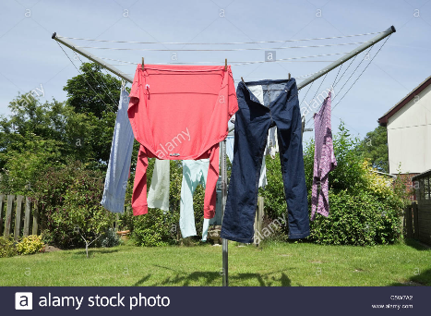

1. Water any plants in the house or in the garden on hot days.

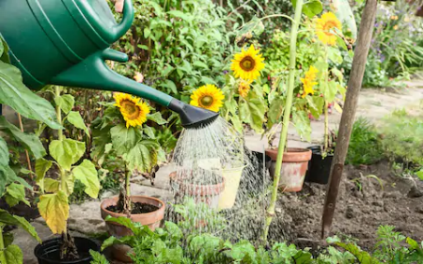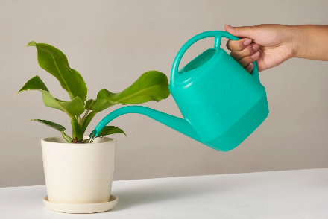

1. Helping out in the garden on dry days, this could mean weeding, planting or brushing/raking up leaves. (Don’t forget to wear gardening gloves).

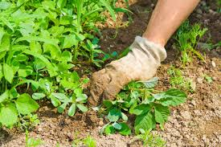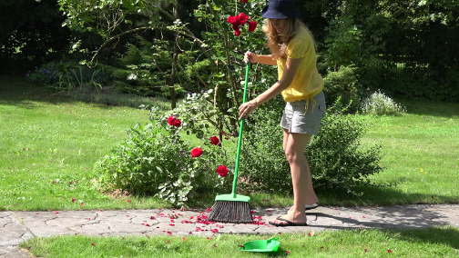

10. Keep things tidy! Make sure you put everything away after using it, whatever it may be. This might include; shoes, games, books, your school work and any equipment.

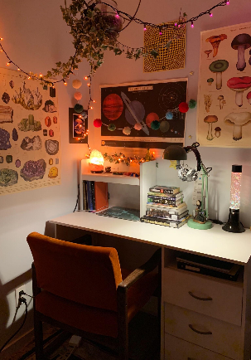

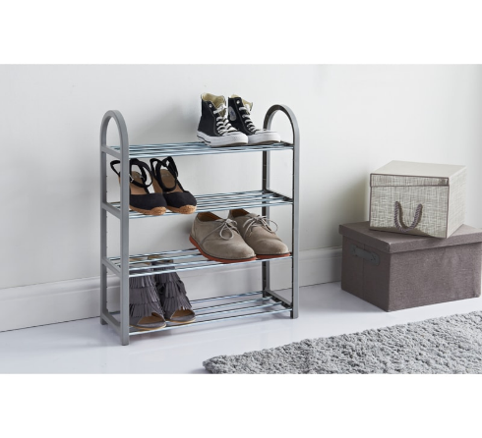

Don’t forget to take photographs of all your hard work around the house and ask an adult to email them to your teacher.