**Our Community Heroes**

A hero can be defined as ‘a person who is admired for their courage, outstanding achievements or noble qualities.’

In the community where you live, there are lots of people who can be described as a hero during the National Lockdown. Below, can you write a short description of what each job is and why it is important, there is a vocabulary box to help you.



______________________________________________________________________________________________________________________________________________________________________________________________________________________________________________________________________________



______________________________________________________________________________________________________________________________________________________________________________________________________________________________________________________________________________



______________________________________________________________________________________________________________________________________________________________________________________________________________________________________________________________________________

______________________________________________________________________________________________________________________________________________________________________________________________________________________________________________________________________________





______________________________________________________________________________________________________________________________________________________________________________________________________________________________________________________________________________

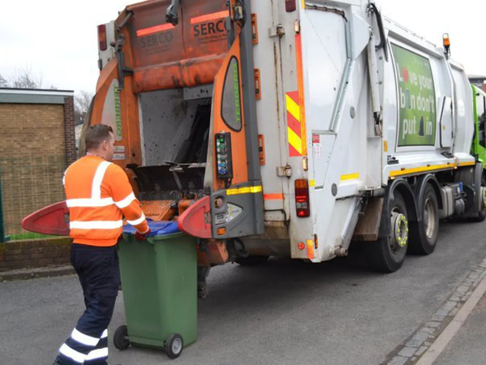

______________________________________________________________________________________________________________________________________________________________________________________________________________________________________________________________________________



______________________________________________________________________________________________________________________________________________________________________________________________________________________________________________________________________________

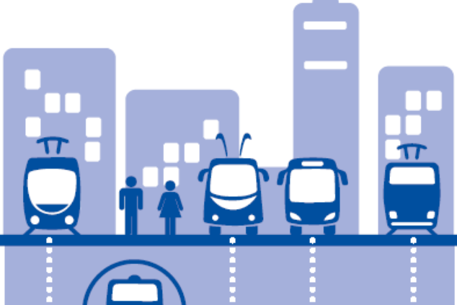

______________________________________________________________________________________________________________________________________________________________________________________________________________________________________________________________________________

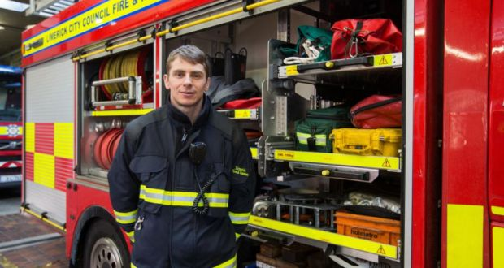

Nurse/Doctor

Police

Engineer

Bin men/women

important

because

essential

community

Postman/postwoman

Paramedic

Vet

Shop Assistant

Firefighters

Factory workers

Public transport driver

**Vocabulary**

Saving lives

______________________________________________________________________________________________________________________________________________________________________________________________________________________________________________________________________________

______________________________________________________________________________________________________________________________________________________________________________________________________________________________________________________________________________

______________________________________________________________________________________________________________________________________________________________________________________________________________________________________________________________________________