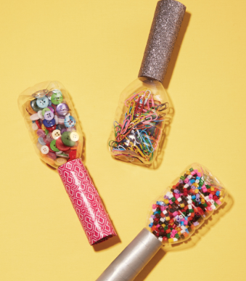
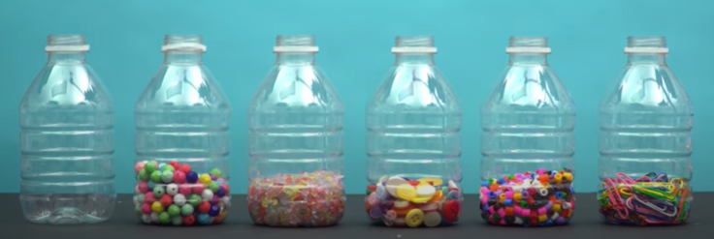
DIY Maracas

You will need;
- Sticky tape (and glue optional)
- Scissors
- Empty plastic bottle and lid
- Something to put inside e.g. beads, buttons, paperclips, pasta or rice.

https://www.youtube.com/watch?v=ZVNU0VR2ETw

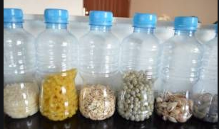

Important: You do NOT need a hot glue gun. Please do not use a hot glue gun, use sticky tape, glue stick or PVA

