Water Xylophone
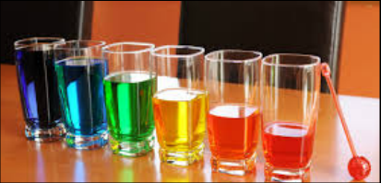
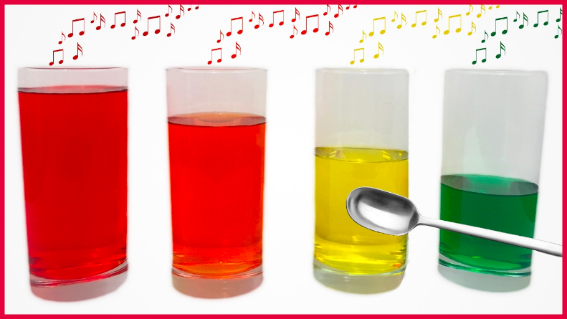

You will need:
- Glass cups
- Water
- Spoon or a skewer
- Food colouring (optional)

Here are two links to show you, how to make your very own water xylophone:

https://www.youtube.com/watch?v=CUkbw2LLkU4

https://www.youtube.com/watch?v=DnDY0jarqOw

