The X-men are worried about Wolverine. They think that his excessive smoking and drinking are getting out of hand. They are concerned about his health and the example he is setting for the younger X-men. Help the team write a letter to Wolverine outlining the health risks of smoking and drinking.
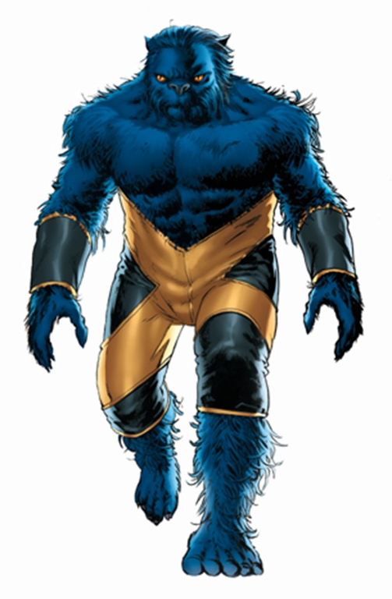
Success Criteria
All: Recall some effects of smoking and drinking on the
body.
Most: Explain how the Liver can be affected by drinking and
the lungs affected by smoking.
Some: Name 2 lung diseases caused by smoking and apply your
understanding to explain how they conditions affect
the functioning of the lungs.

Include:
- a page border
- Some pictures
- A Title

