Copy My Rhythm Activity.
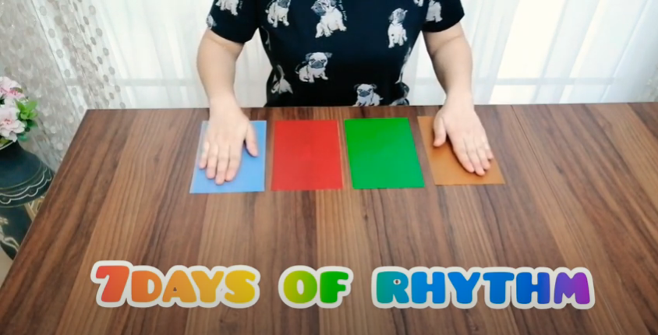
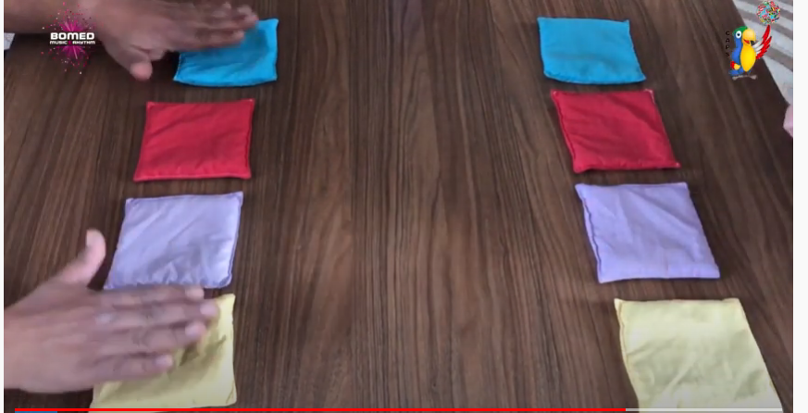

You will need:
- 4 different coloured pieces of paper or beanbags (if you don’t have these, use your imagination colour the paper or find something else you can use.)
- A partner
https://www.youtube.com/watch?v=oly5aKQk-28

https://www.youtube.com/watch?v=2OYohXoTugo

If you haven’t got a partner to play with you, let’s see if you can beat this YouTuber.

https://www.youtube.com/watch?v=oM8Zb29DtHY

