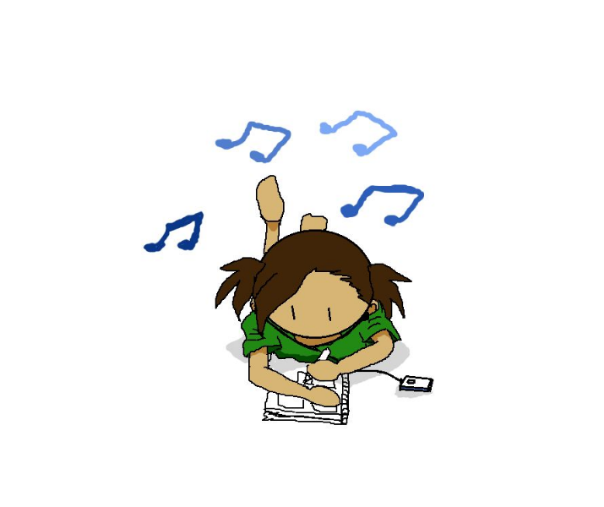
Virtual Art/Music Party

https://www.youtube.com/watch?v=XgCBntw2Iiw

Listen to the three pieces of music the lady plays, draw or write; what you think is happening and how it makes you feel.

All you need:
- Pen/Pencil
- Paper
- Coloured pencils/ felt tips/ chalk/paint etc… (optional)

