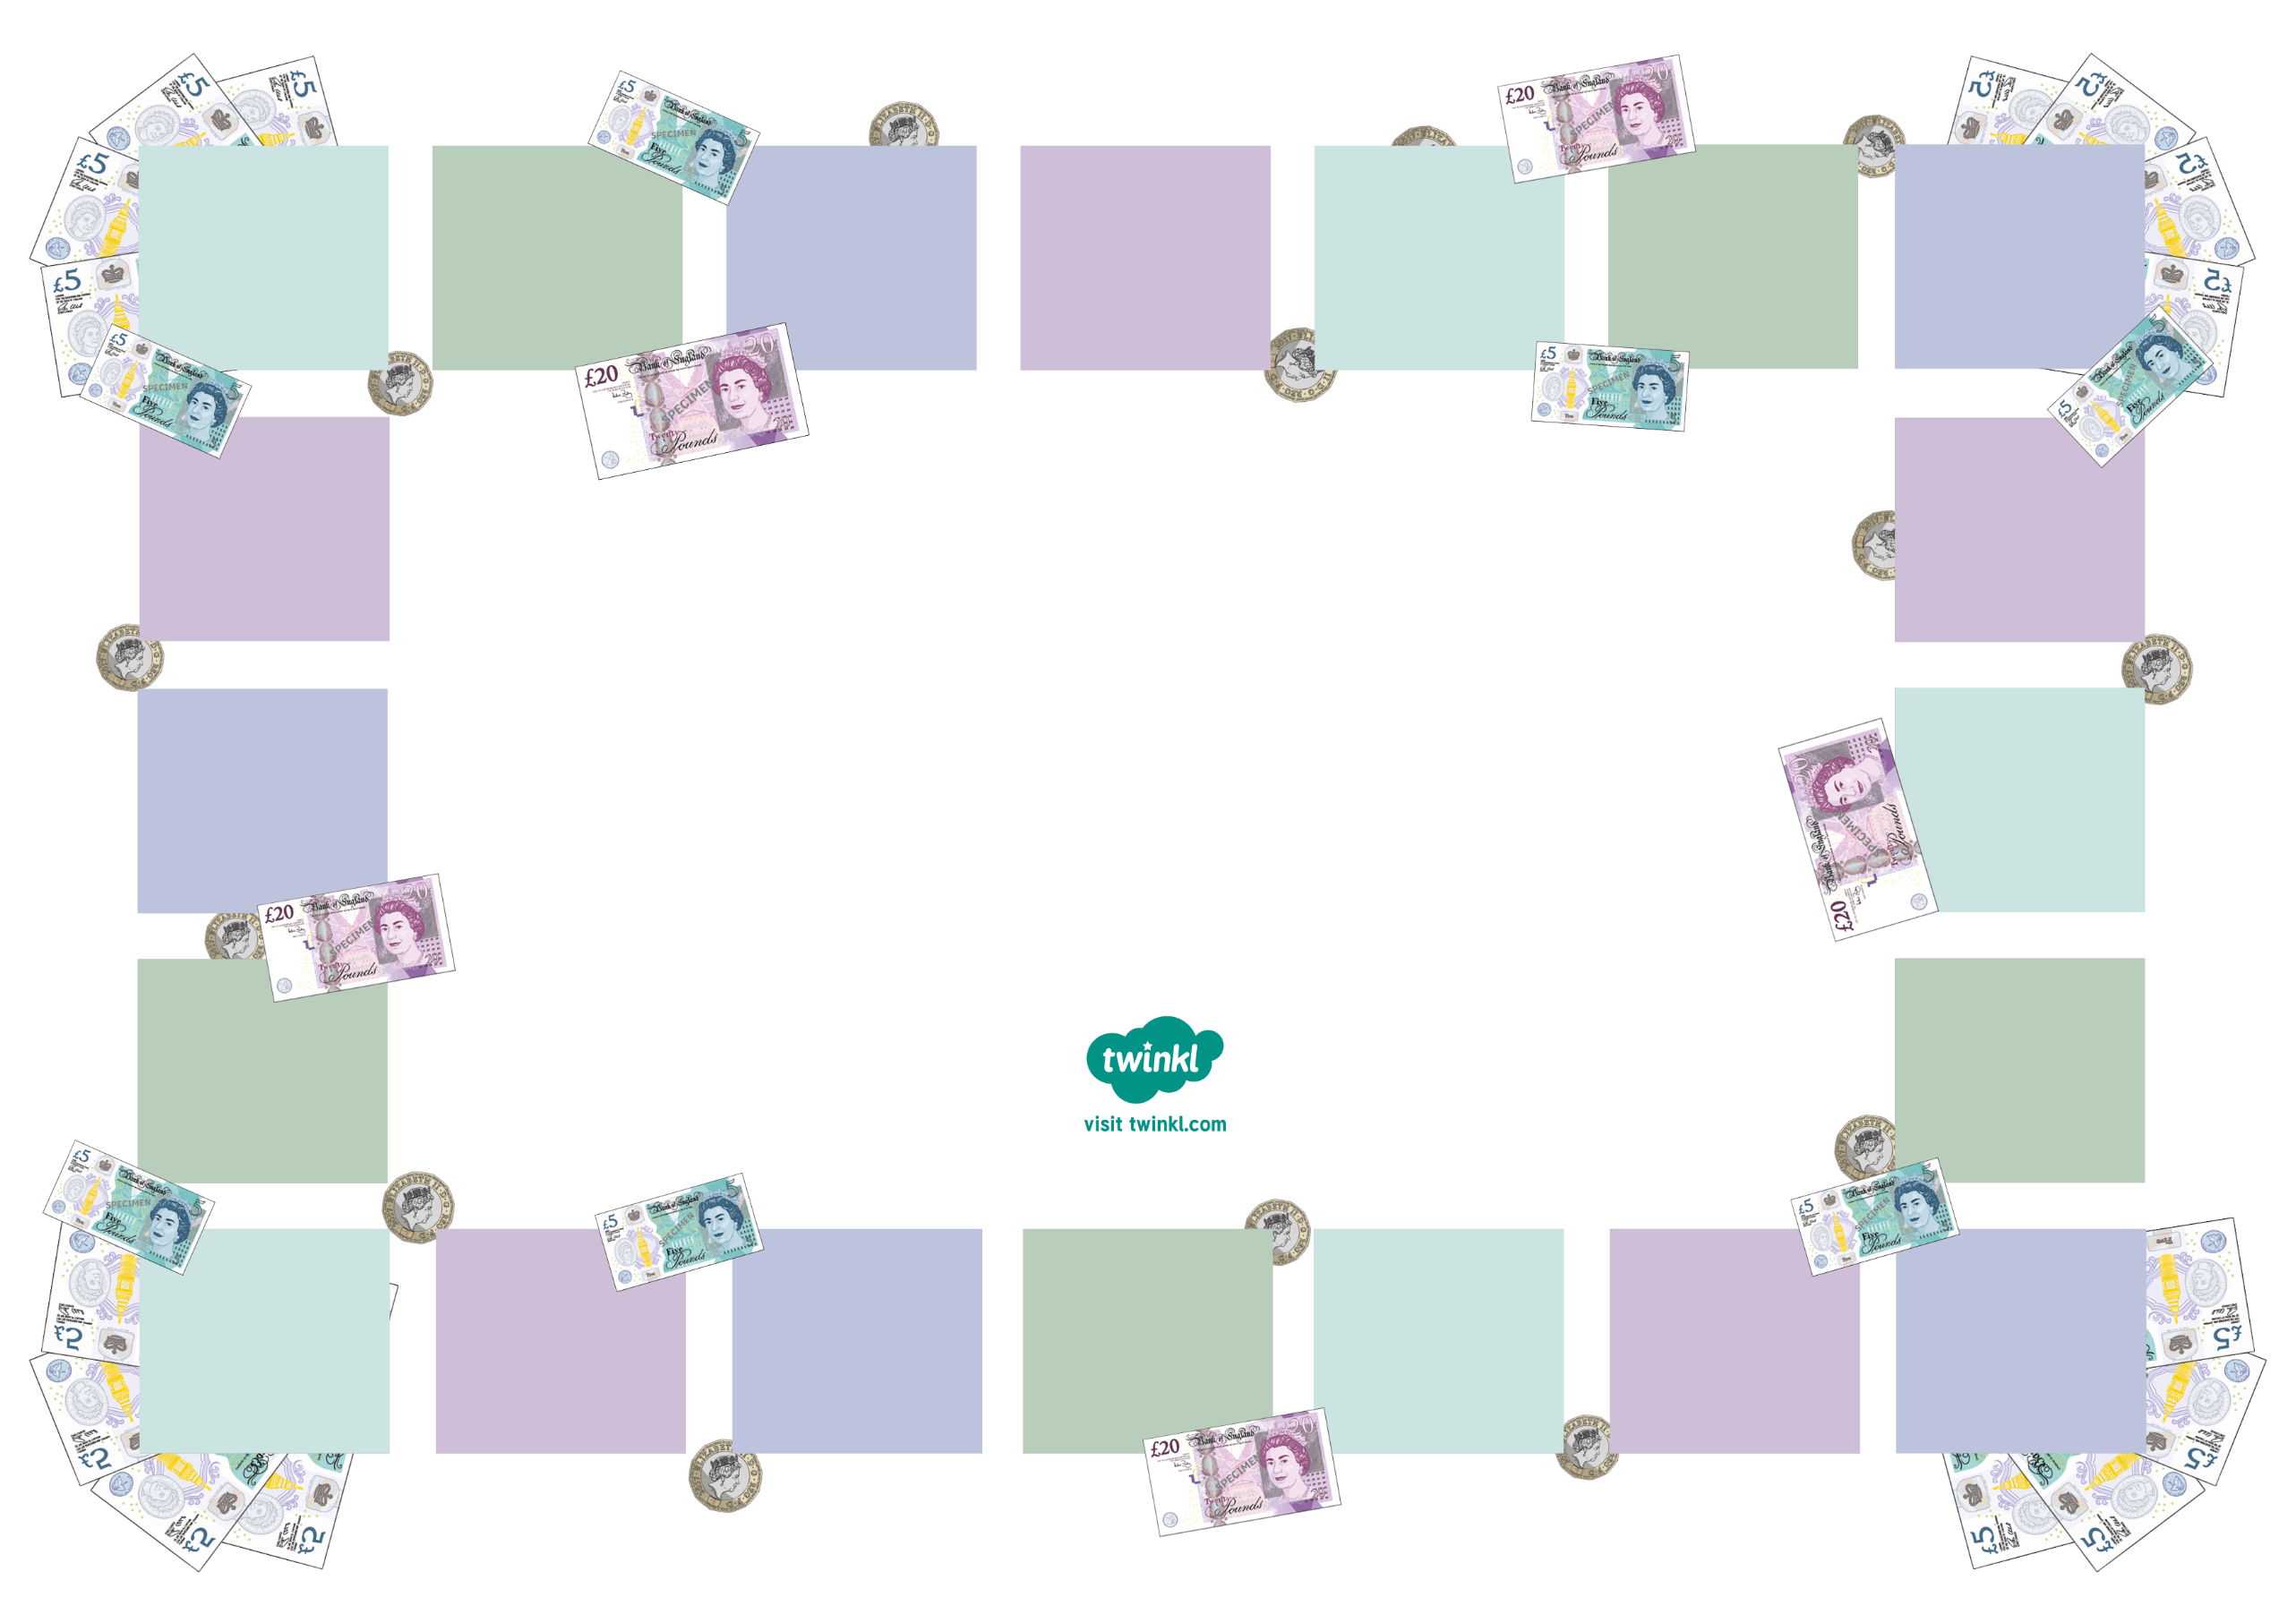
4
5
6
7
8
9
10
1
2
3
11
12
13
14
15
16
17
18
19
Use this sheet to design your own board game around buying and selling products. In the game, players will need to borrow money from each other. Can you create budgets and salaries for players to work from? You could even include task cards where players get paid a bonus or pay a penalty!

Money Spending Board Game
Task Cards
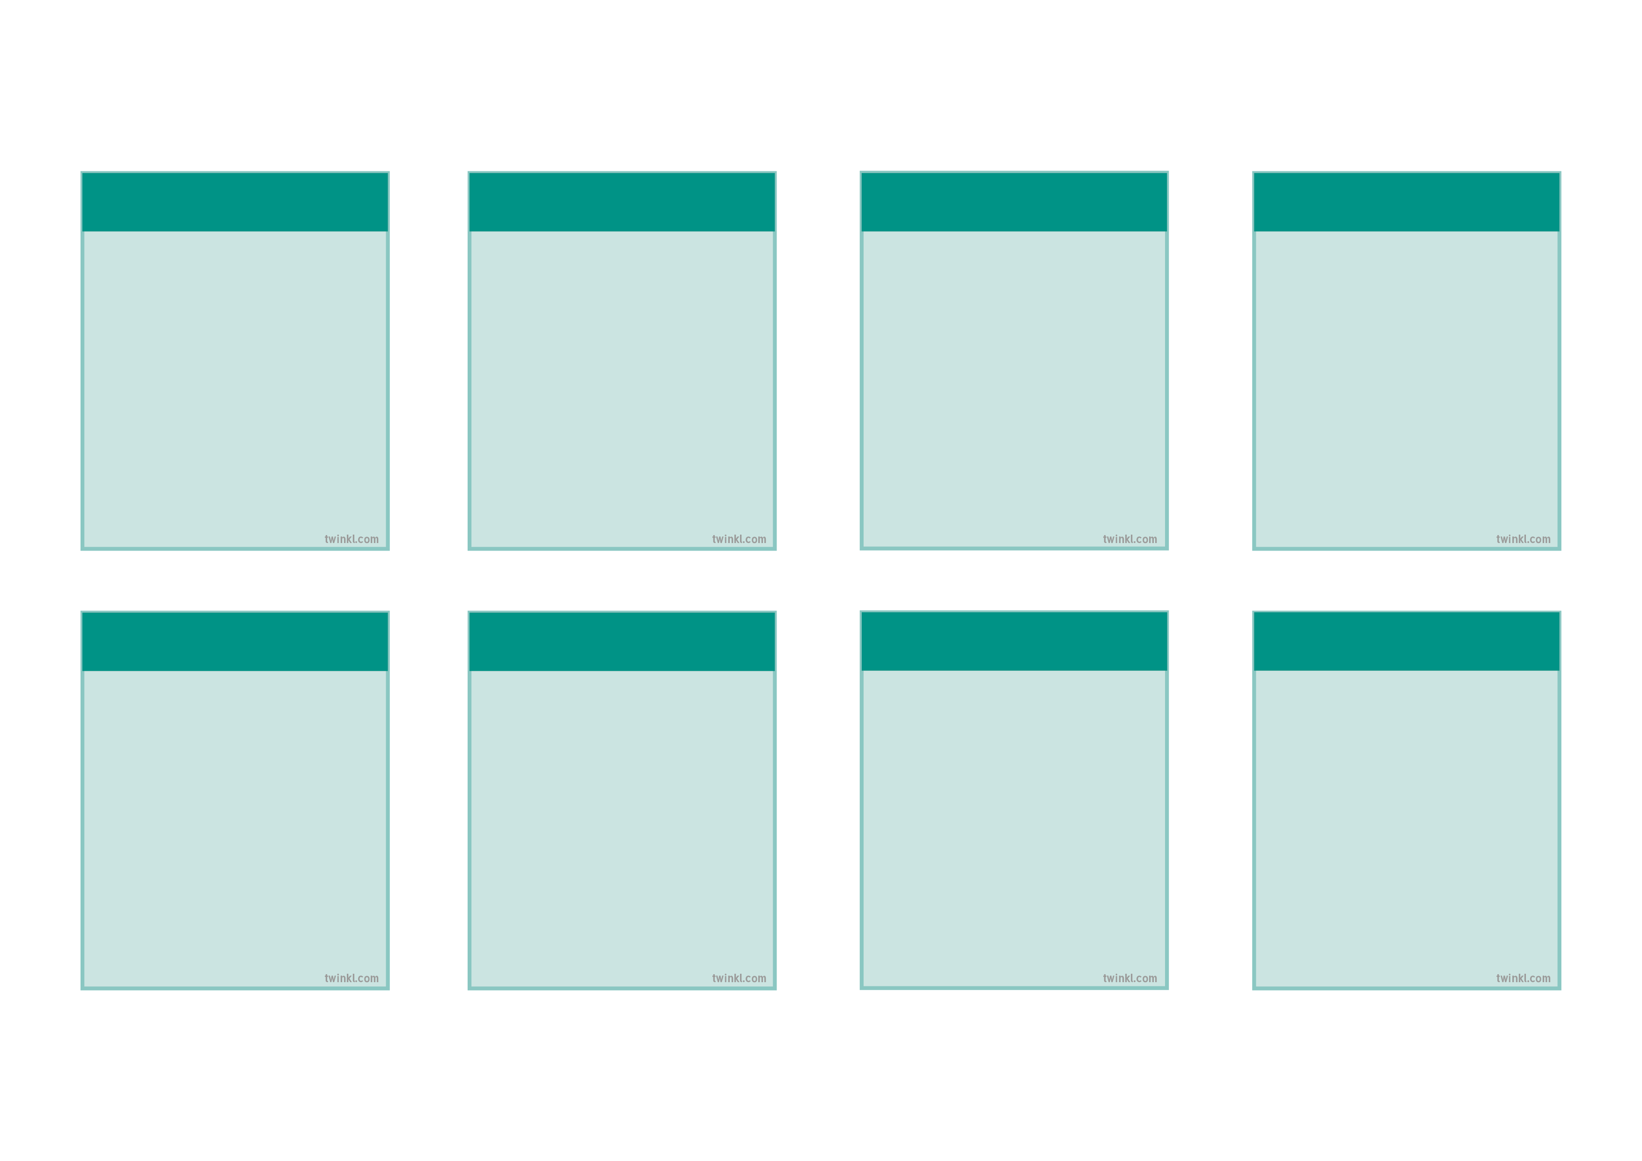
Task Cards
Task Cards
Task Cards
Task Cards
Task Cards
Task Cards
Task Cards
Task Cards

