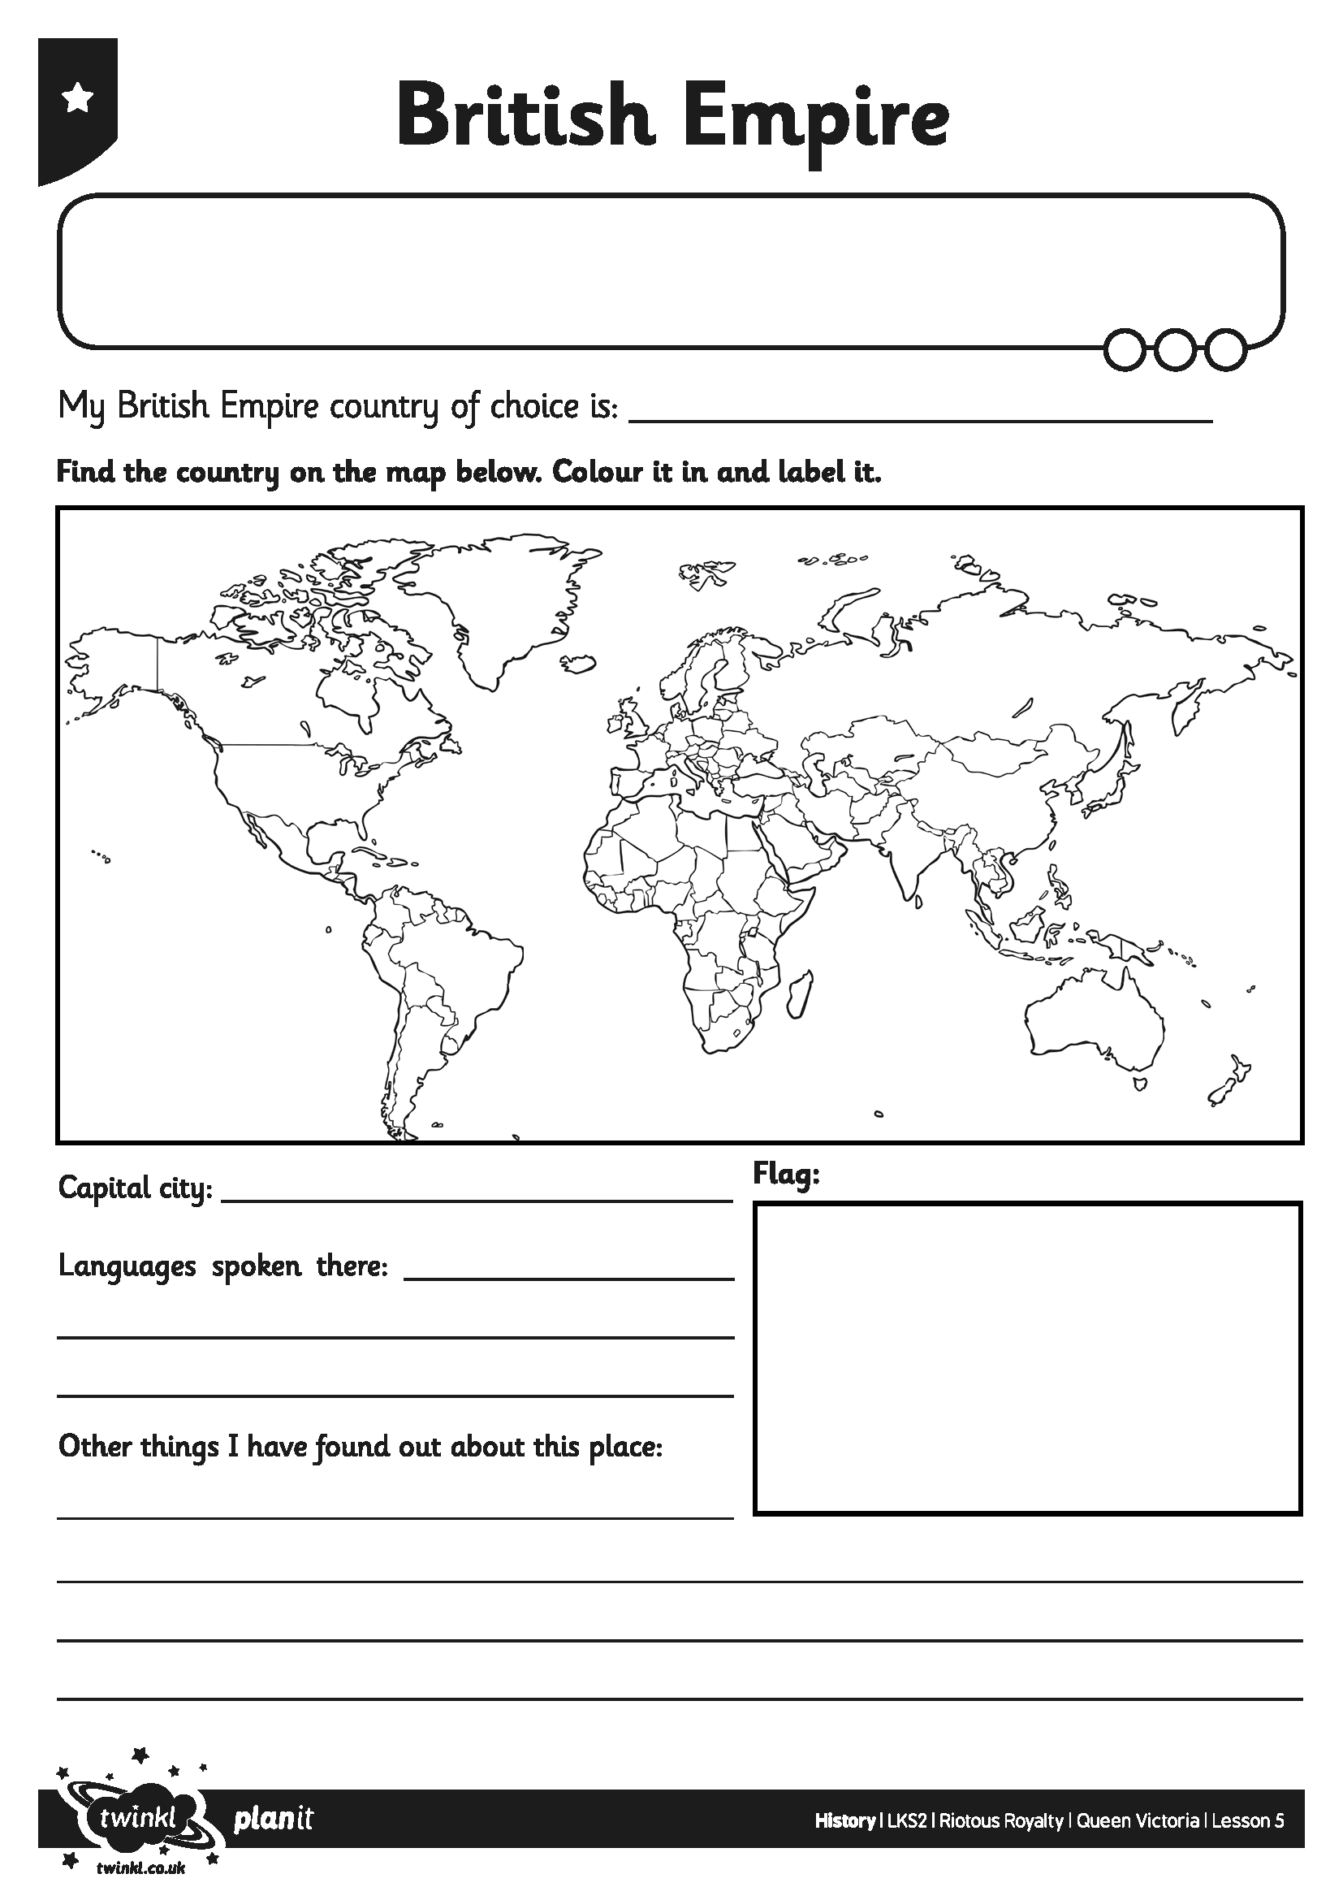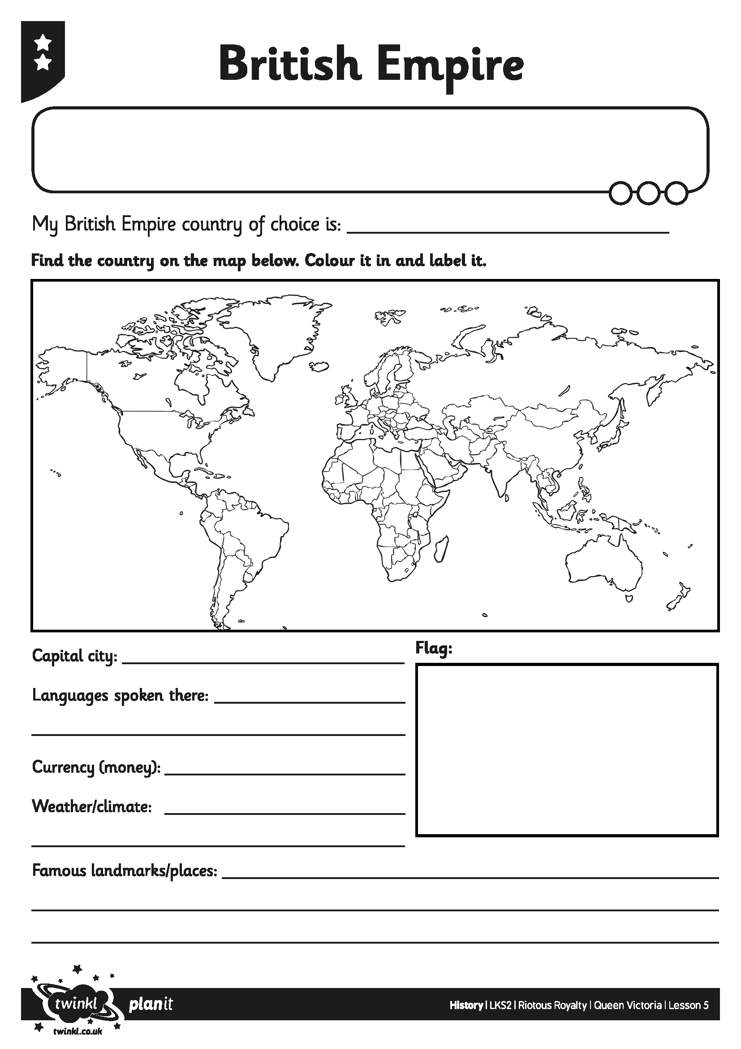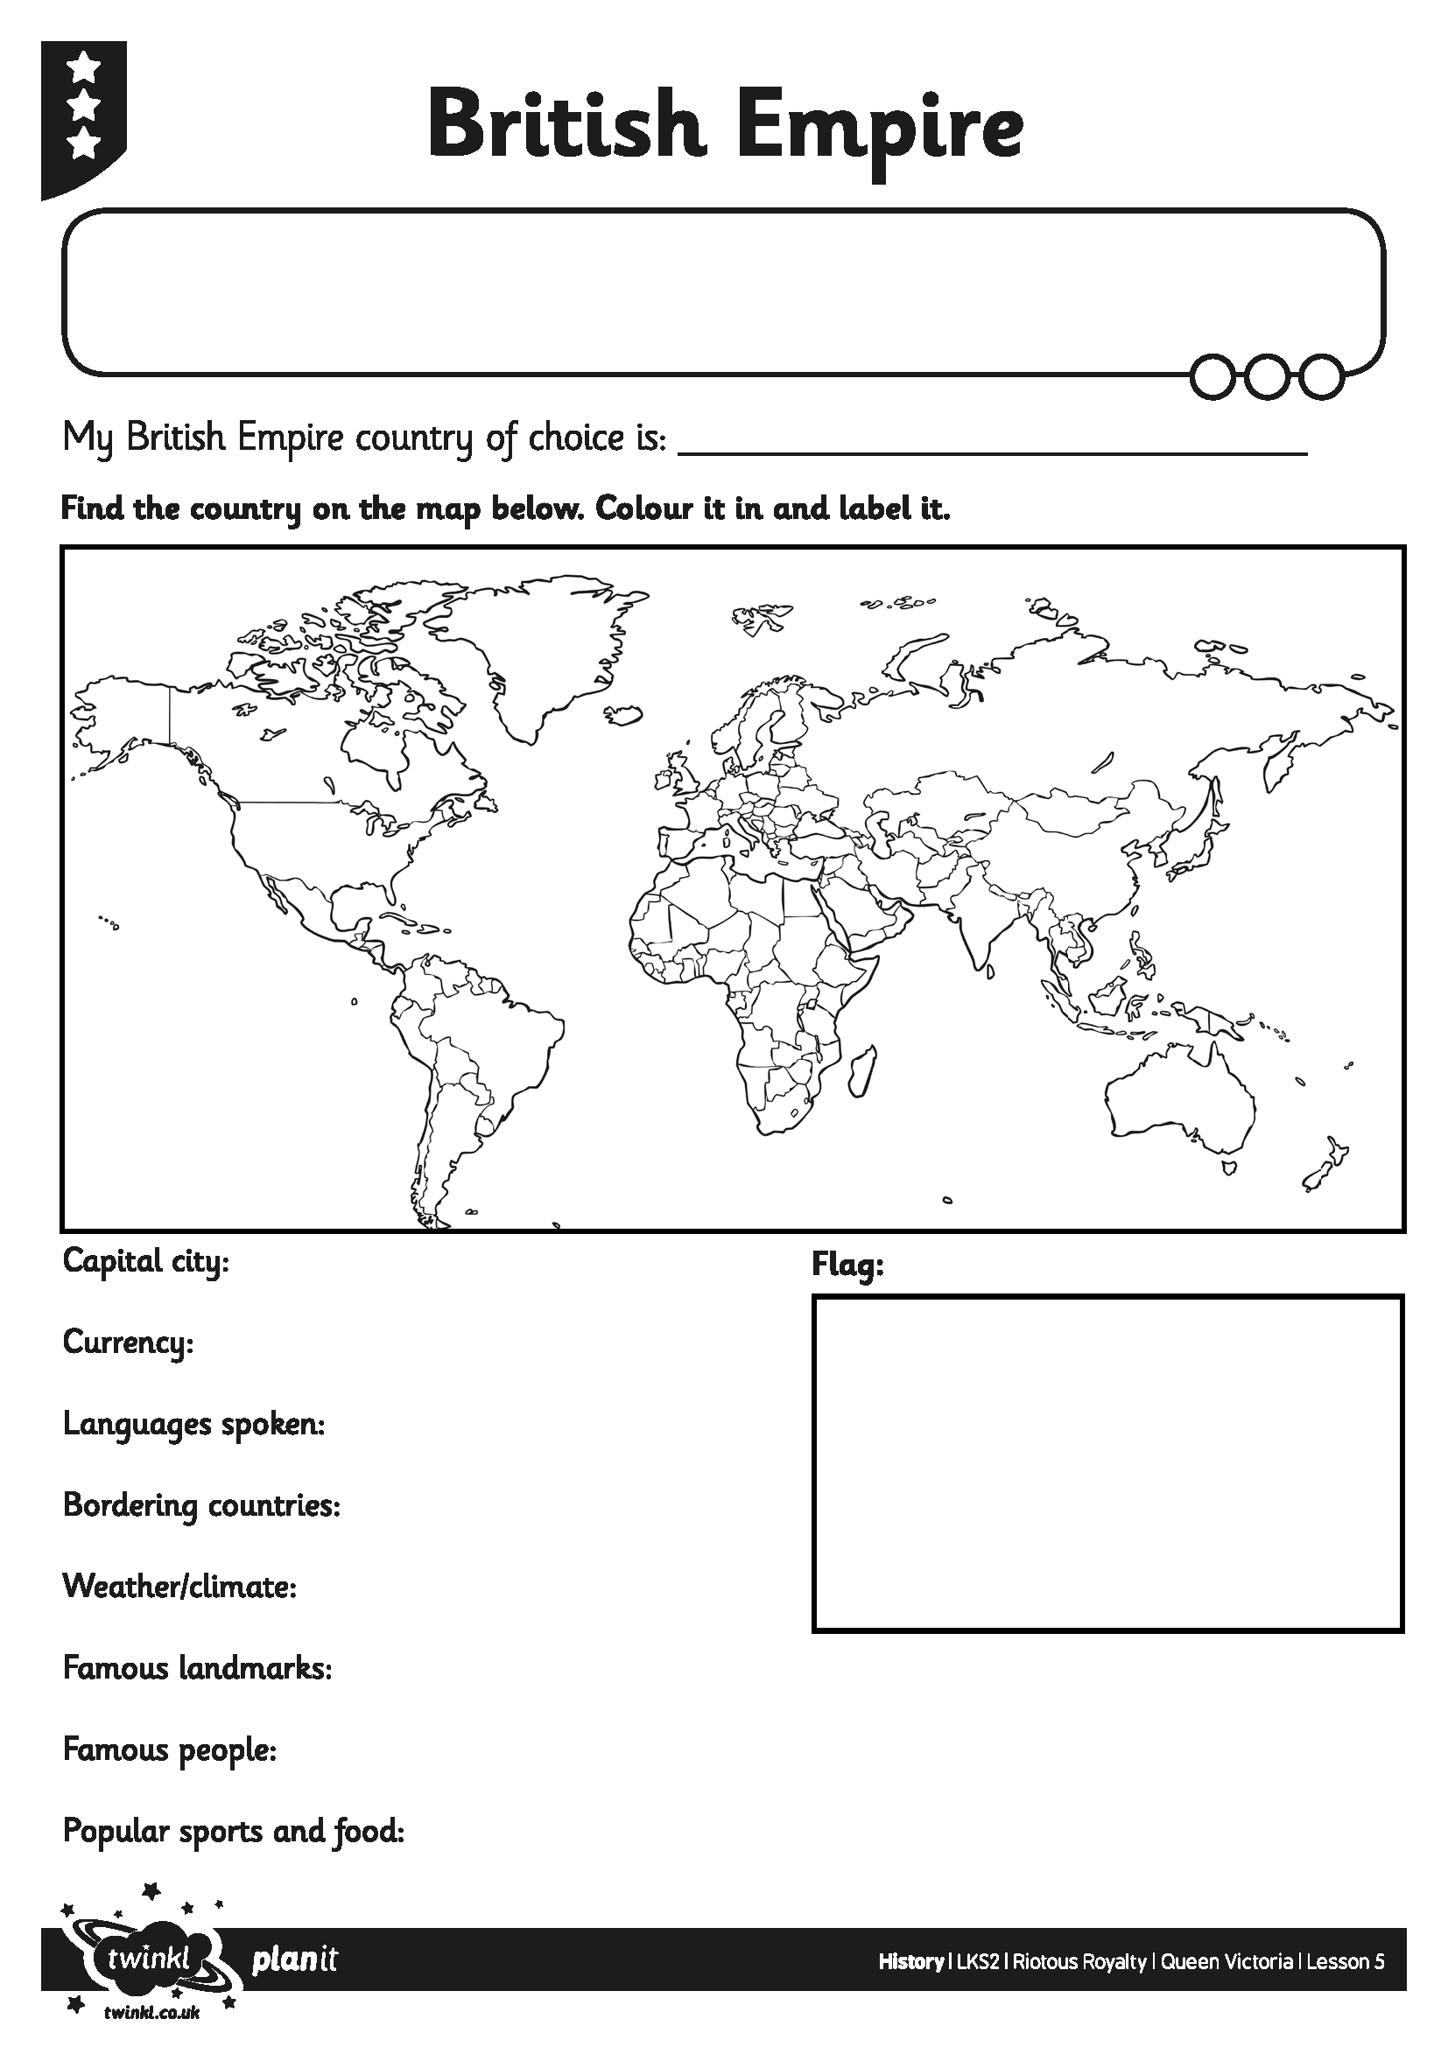
I can understand what the British Empire meant in Victorian Britain.

I can understand what the British Empire meant in Victorian Britain.

I can understand what the British Empire meant in Victorian Britain.

