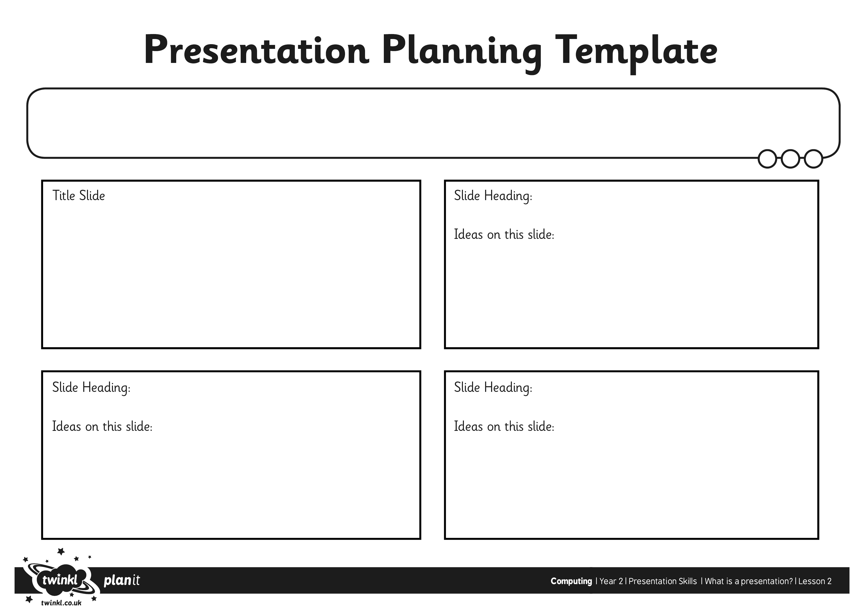
I can organise ideas for a presentation.

