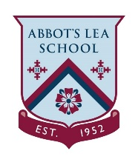
Turn Taking – Animal Bingo
Twinkle link - https://www.twinkl.co.uk/resource/t-s-574-who-wild-animals-lotto-bingo

How does this resource excite and engage children's learning?
A lotto game focusing on the use and understanding of the question word ‘who’. This game can also be used as a listening game and to support the wild animal vocabulary. This game will be useful for speech and language therapists, teachers and parents.

Instructions
Play with as many players as long as there are more than two taking part and one separate player is the bingo.
The bingo person will either use the written card or the picture, they will select at random.
If the person has the animal on their board cover with one of the counters.
When all animals have been found on the line across is known as a “line” when all the animals have been found the person must shout “bingo”.

BINGO CALLER CARDS:
Cut below cards and mix them up use whichever cards appropriate for age group.

Each player should be given a board with animals and a counters board to use during the game.

