

**Turn Taking – Pirate Treasure Game**

**Twinkle link -** <https://www.twinkl.co.uk/resource/t-t-5273-pirate-treasure-hunt-board-game>

How can I use treasure hunt?

Print, cut and laminate this Pirate Treasure Hunt Board Game for a lovely pirate themed game. Follow the simple instructions to see who will win. Great for encouraging turn-taking, as well as practising basic counting, addition and subtraction.

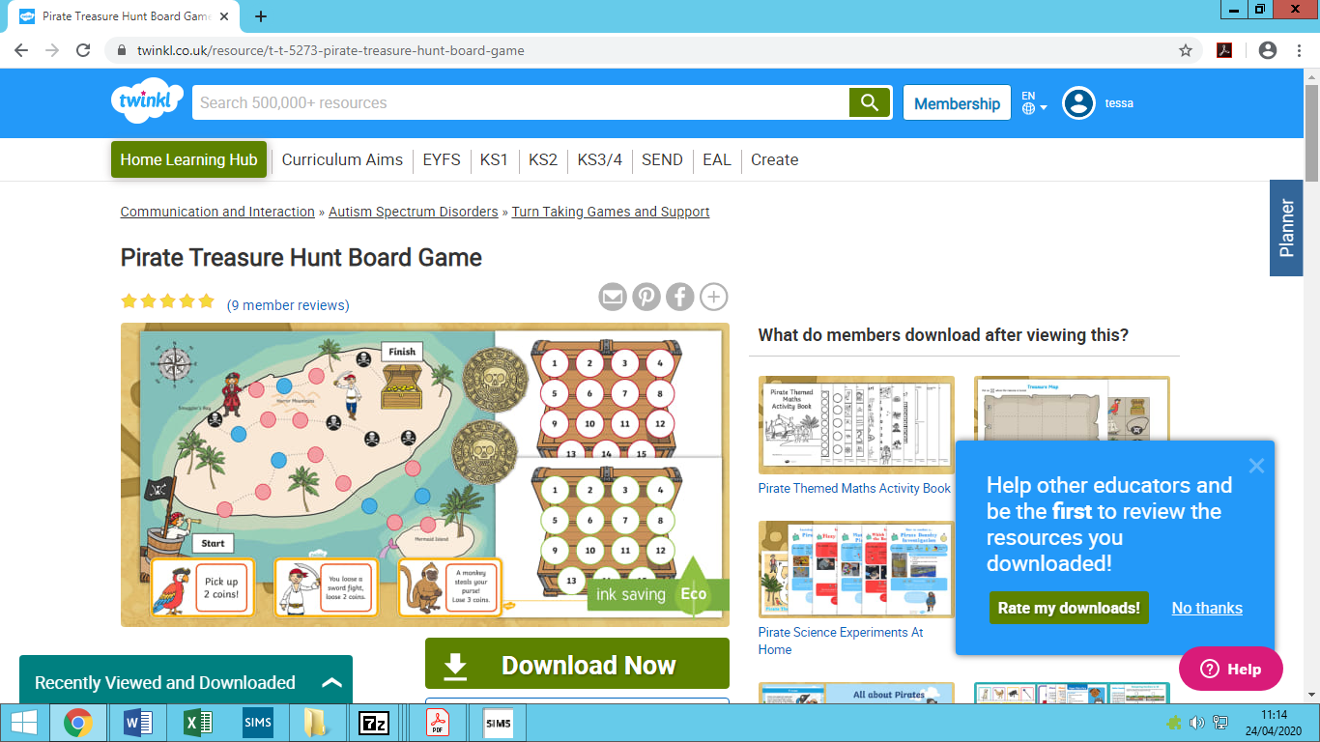

**You will need:**

1. 1 game board,
2. A treasure chest board for each player
3. Gold coins
4. Coloured counters
5. Chance cards
6. Dice

**Insturctions**

Each player starts with 3 coins in their chest. Roll the dice and move your counter along the coloured circles. If you land on a red circle, pick up a chance card. If you land on a black circle, go back 3 spaces. When all the players have reached the end, count up your gold coins. The winner is the pirate with the most coins.

