BUG HOTEL

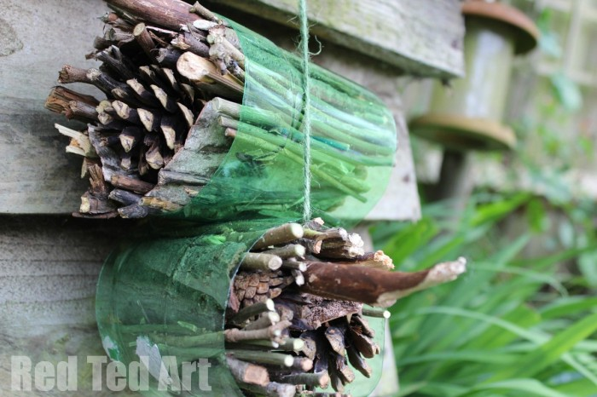

You will need:
. large plastic bottle cut into two cylinders
. sticks
. pine cones
. bark
. bamboo
. corn

- Cut the bottle width down to size.

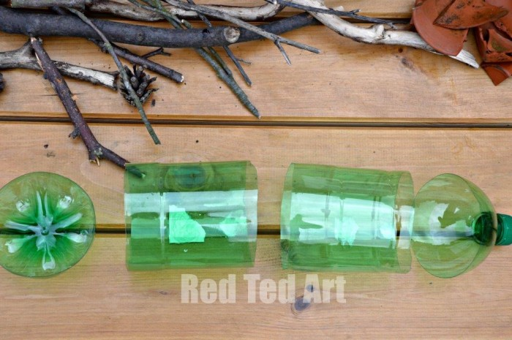

- Arrange your materials.
Check what materials you have and arrange by size and texture – snap twigs to make larger and bigger ones.

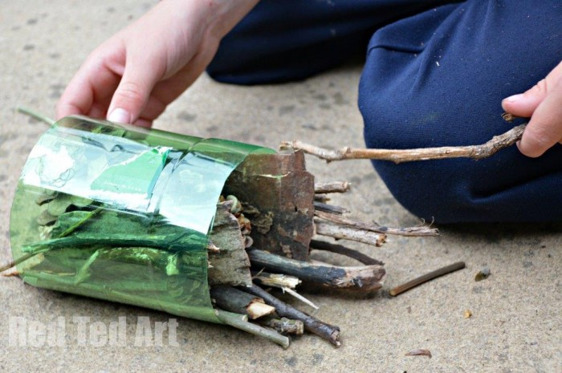
- Decide on the insect hotel location and add twine for hanging. (As above)
If you plan to hang your bug hotel, loop some garden twine around then start layering your bug hotel.

- Make the insect hotel nice and cosy.
Stuff it to make it nice and firm so it doesn’t get blown about!

