Barriers and How to Overcome Them

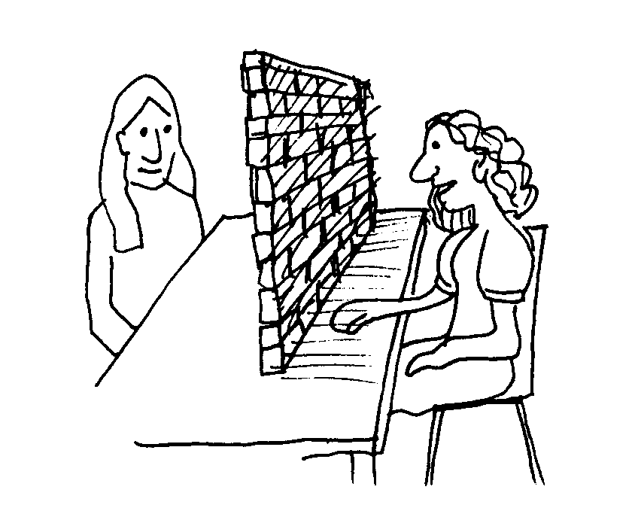
Getting a job is always a challenge, but it can be even more difficult if you feel worried about your skills and are unsure how and where to look.

The following have been identified as the most common areas where people feel they lack knowledge and confidence –
- Not being organised enough to apply for posts
- Not comfortable using computers
- Difficulty using basic technology
- Unfamiliar with how to use office equipment
- Difficulty organising their workload
- Communication - such as following oral instructions
- Handwriting and spelling
- Memory and concentration
- What do you feel your barriers are to work?

- Memory and concentr

5. Looking at the points above, choose three things that could be used to help you overcome your own barriers in the workplace.
e.g. – “I have trouble remembering information, so I could use a diary and write lists”

4. Is there any way you can improve your chances of getting into work? (e.g. speculative letters, work trial or voluntary work)

- How confident do you feel about looking for jobs?

- How can you improve your confidence and knowledge in these areas?

