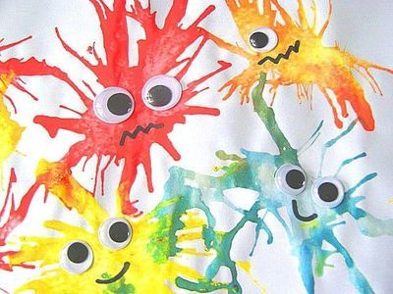
Blow Paint
What you need:
- Paper
- Coloured Paint
- Straw
- Felt-tip pen

What to do:
- First, put a blob of paint onto your paper.

- Then, with your straw start to blow your blob of paint in different directions.

- Next, add another blob of different coloured paint to your paper and blow in different directions.

- Repeat as many times as you like.

- Finally, once your blobs have dried, using a felt-tip you can give your blobs some eyes and turn them into mini monsters.

- Have fun!!!

Video to demonstrate - https://www.youtube.com/watch?v=8o5zT1_aKf8

