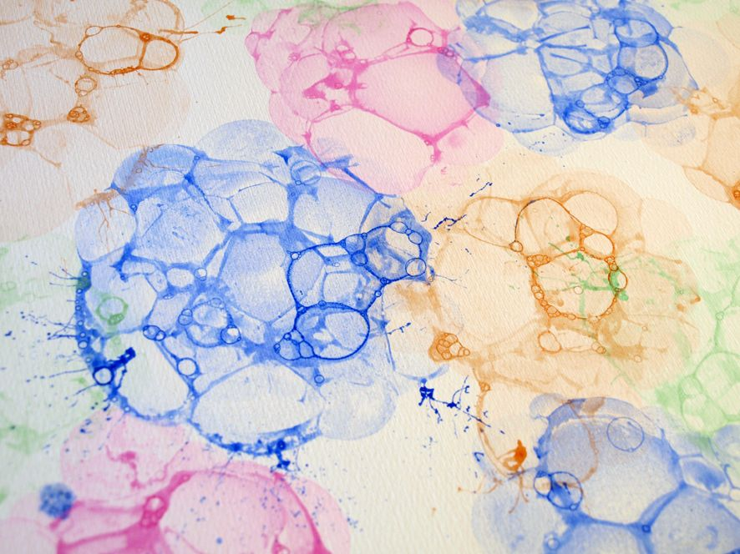
Bubble Painting
What you need:
- Paper
- Plastic cup (mug or bowl will do too)
- Coloured Paint
- Water
- Spoon
- Straw

What to do:
- First, using a spoon, mix the water and coloured paint in a plastic cup.

- Next, with your straw, carefully blow the mixture until lots of bubbles start to form. The bubbles must come over the top of the cup. Be careful not to drink any of the mixture.

- Then, use your paper to place over the top of the cup making sure it touches the bubbles.

- Repeat blowing the bubbles and placing the paper over the top. You can try using different coloured paints if you want to.

- Have fun!!!

Video to demonstrate -https://www.youtube.com/watch?v=z4i3Pp_ciwA

