CHALK GAME
“Let it grow”

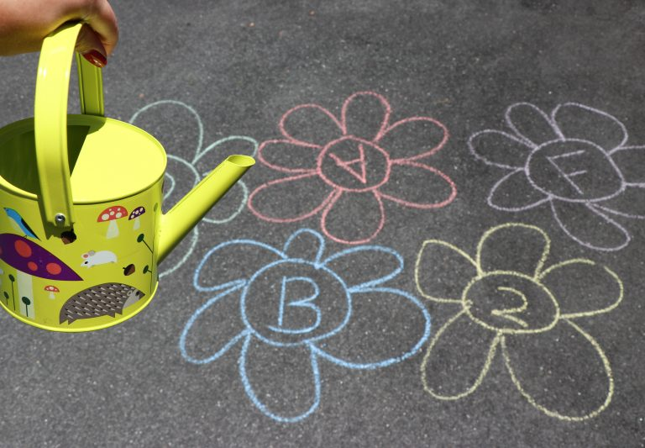

Find the letter that starts with the word bat, ball etc.
Found the right letter then pour water over flower and “watch it grow”.
You need: Chalk, little watering can.

