Canadian Rocky Road

Ingredients

- 200g dark chocolate  - 1 tsp. syrup  - 75g margarine / butter  - 75g mini marshmallows | - 120g digestive biscuits (broken into chunks)  - a handful of raisins and/or rice krispies
 | - 50g white chocolate

Method

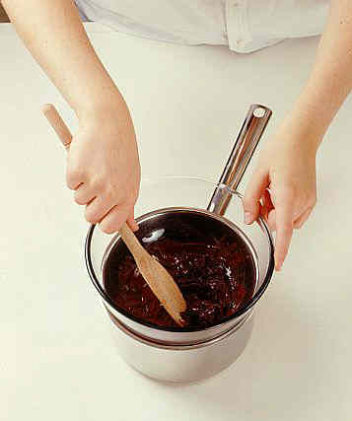 | 1. Melt the chocolate, butter / margarine and syrup in a bowl suspended over a pan of boiling water, making sure that the water does not touch the bowl.
 | 2. Once the chocolate has melted add the rest of the ingredients and mix well, but make sure that you don't break up the biscuits too much.
 | 3. Pour into a baking tray, which has been lined with parchment or greaseproof paper. Make sure it reaches the corners and is leveled out.
 | Extra! – If you have time, heat up the white chocolate and drizzle it carefully on the top to create a snowy effect.
 | 4. Place in the refrigerator for a minimum of 4 hours.
 | 5. Once the mix has set, tip out and cut into squares. Dust with icing sugar for that extra snowy effect!

