Key stage 2 Home Learning
Chatta Challenge!

Once you have joined the Chatta Club at www.chattalearning.com, you can access Chatta on your tablet at home.
Here are this week’s Chatta Challenges! Choose as many as you would like to do. Don’t forget to email them to your class teacher!
Activity 1 | Activity 2
Make a chat to introduce what a Mini beast is. | Make a chat to record all the different Mini beasts you can see?  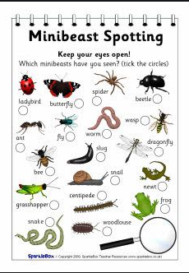
Activity 3 | Activity 4
Make a chat to explain how your garden helps Mini beasts? | Make a chat to tell us how many mini beasts you have counted in your garden.  