Key stage 2 Home Learning
Chatta Challenge!

Once you have joined the Chatta Club at www.chattalearning.com, you can access Chatta on your tablet at home.
Here are this week’s Chatta Challenges! Choose as many as you would like to do. Don’t forget to email them to your class teacher!
Activity 1 | Activity 2
Make a chat to show a step by step of breakfast routine | Make a chat to explain how to make pancakes
Activity 3 | Activity 4
Make a chat to retell The smartest giant in town.  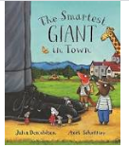 | Make a chat to retell a time you went to the shop and what you bought.

