Key stage 2 Home Learning
Chatta Challenge!

Once you have joined the Chatta Club at www.chattalearning.com, you can access Chatta on your tablet at home.
Here are this week’s Chatta Challenges! Choose as many as you would like to do. Don’t forget to email them to your class teacher!
Activity 1 | Activity 2
Make a chat to introduce a Bumblebee  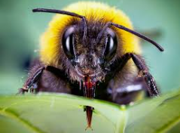 | Make a chat to record the important job a Bumblebee has.  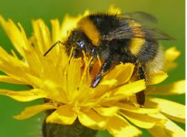
Activity 3 | Activity 4
Make a chat to explain how we can help Bumblebee’s?  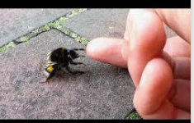 | Make a chat to tell us what a Bumblebee makes?  