Key stage 2 Home Learning
Chatta Challenge!

Once you have joined the Chatta Club at www.chattalearning.com, you can access Chatta on your tablet at home.
Here are this week’s Chatta Challenges! Choose as many as you would like to do. Don’t forget to email them to your class teacher!
Activity 1 | Activity 2
Make a chat to introduce Italy. | Make a chat to record all the different Italian foods  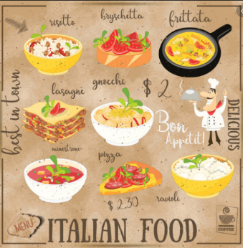
Activity 3 | Activity 4
Make a chat to record a famous Italian land mark. | Make a chat to tell us the capital of Italy?

