Key stage 2 Home Learning
Chatta Challenge!

Once you have joined the Chatta Club at www.chattalearning.com, you can access Chatta on your tablet at home.
Here are this week’s Chatta Challenges! Choose as many as you would like to do. Don’t forget to email them to your class teacher!
Activity 1 | Activity 2
Make a chat to introduce you as a hero. | Make a chat to explain what your super power is.
Activity 3 | Activity 4
Make a chat to retell your very own hero story.  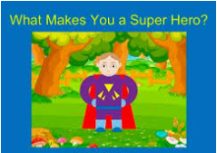 | Make a chat to retell a time you were someone else’s hero.

