Key stage 2 Home Learning
Chatta Challenge!

Once you have joined the Chatta Club at www.chattalearning.com, you can access Chatta on your tablet at home.
Here are this week’s Chatta Challenges! Choose as many as you would like to do. Don’t forget to email them to your class teacher!
Activity 1 | Activity 2
Make a chat to introduce your own hero. | Make a chat to explain why they are your super hero.
Activity 3 | Activity 4
Make a chat to retell a time when they were your hero.  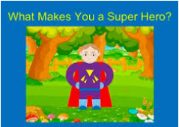 | Make a chat to retell a time they were someone else’s hero?

