KS5 Home Learning
Chatta Challenge!

Once you have joined the Chatta Club at www.chattalearning.com, you can access Chatta on your tablet at home.
Here are this week’s Chatta Challenges! Choose as many as you would like to do. Don’t forget to email them to your class teacher!
Activity 1 | Activity 2
Make a chat to describe someone you think is a hero. | Make a chat that gives directions on how to get to Abbots Lea School from the City Centre.  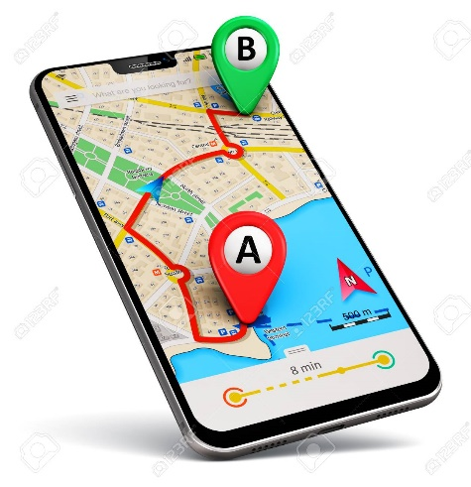
Activity 3 | Activity 4
Make a chat to detail your self-isolation daily routine. | Make a chat to talk about different members of your family.

