KS5 Home Learning
Chatta Challenge!

Once you have joined the Chatta Club at www.chattalearning.com, you can access Chatta on your tablet at home.
Here are this week’s Chatta Challenges! Choose as many as you would like to do. Don’t forget to email them to your class teacher!
Activity 1 | Activity 2
Make a chat to deliver a speech in the style of Martin Luther King’s ‘I have a dream…” | Make a chat that shows the instructions for building something.  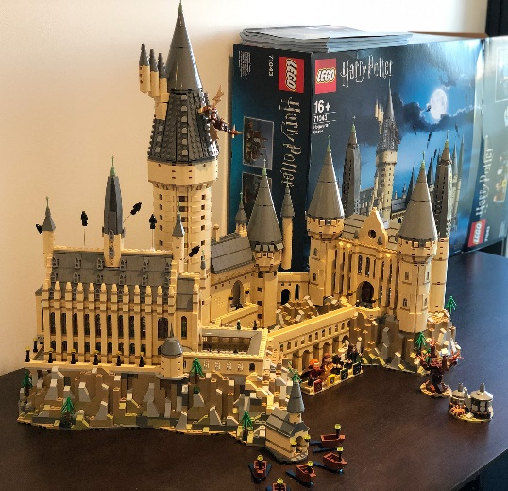
Activity 3 | Activity 4
Make a chat to interview a member of your family about their lockdown experience. | Make a chat to plan a community day trip for when we return to school.

