Chatta User Guide for Parents

Sign up to the Chatta Club at www.chattalearning.com  This may take 24 hours to activate but it is usually much sooner than this. | 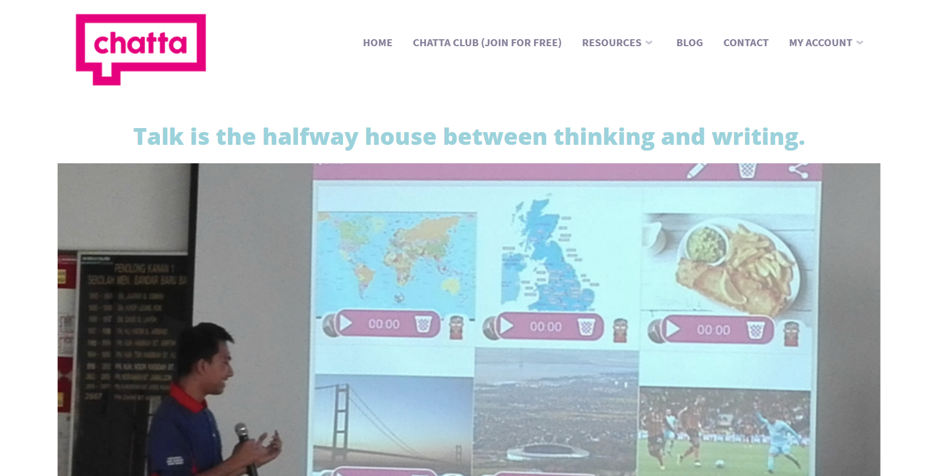
Download Chatta from the App Store and log in.

Use your email address and the password is ch@tt@club

Create new teacher – this will be you as the parent. | 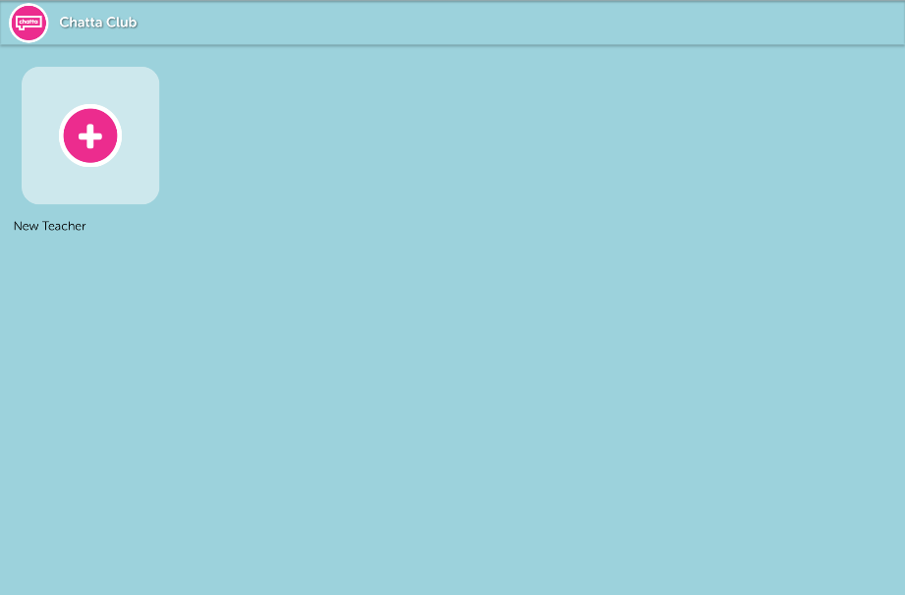
Create new child | 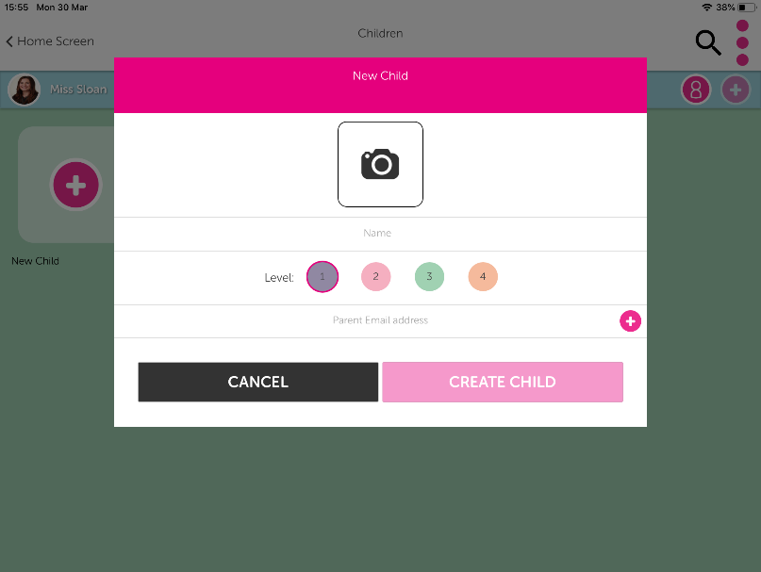
Create new chat. | 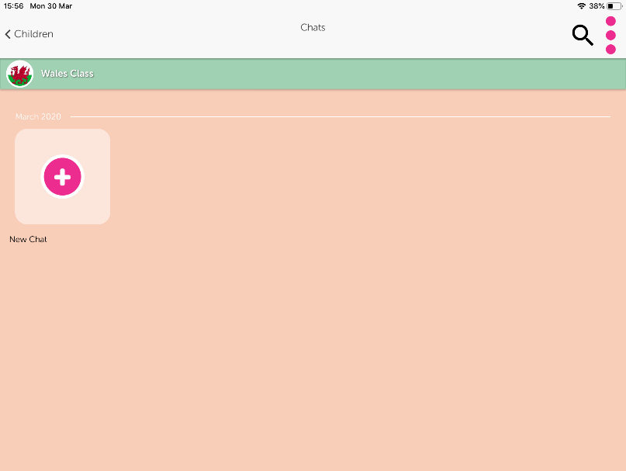
Choose how many tiles you would like it to be and press ‘create chat’. | 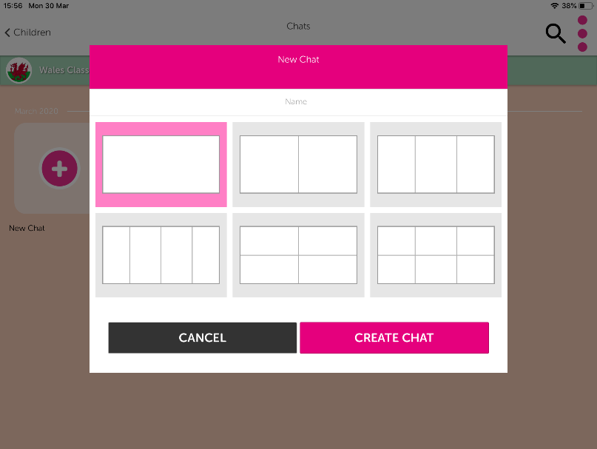
It should now look like this. | 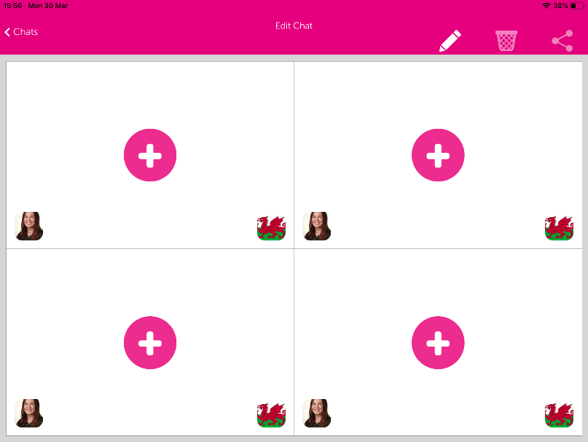
Press the add sign in the first tile and add in your photograh or picture. This could be a saved photograph/picture to ‘my photos’ or it could be a photograph taken in the moment. | 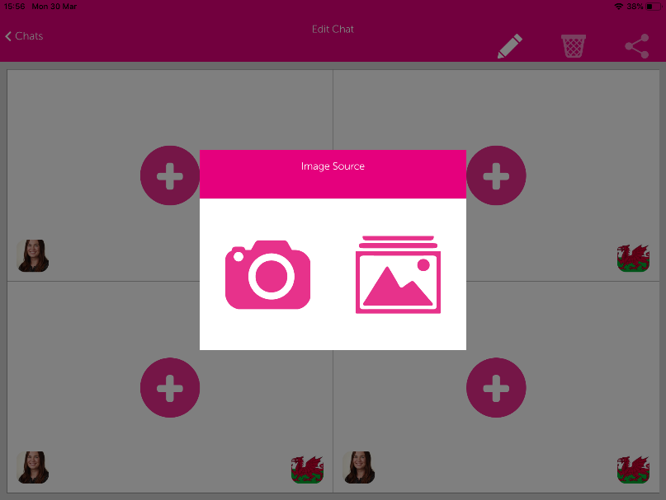
Once you have all your photographs/pictures in place you are ready to discuss them and model language/sentences. | 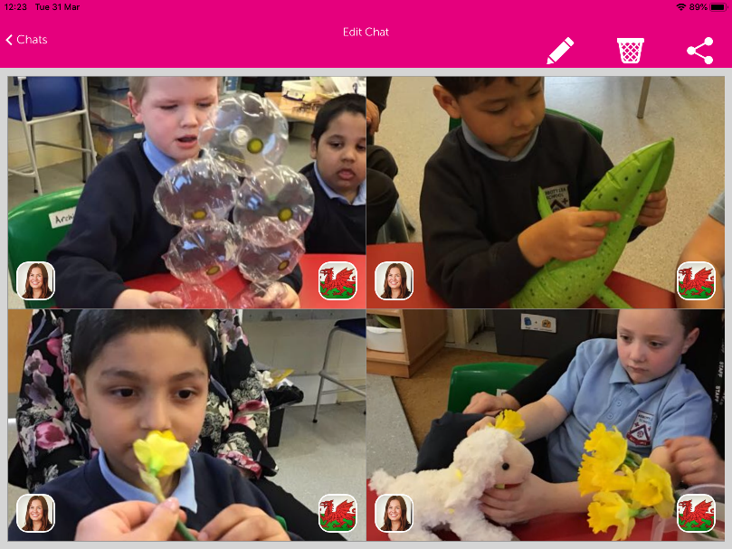
Press on the left hand icon of each photograph/picture to record your voice as the teacher/parent. Now is the time for the pupils to really practice their verbal communication. | 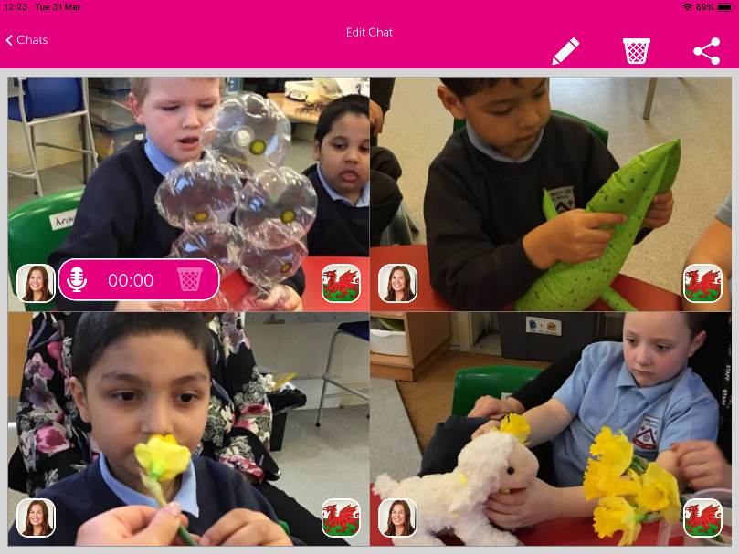
Press the right hand icon of each photograph/picture to record the pupils speaking. This doesn’t have to be exactly what you have modelled, it can be in their own words. | 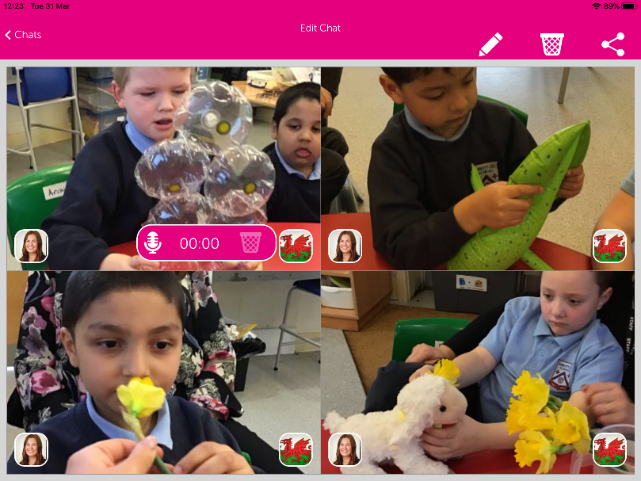
Press the share icon in the top right hand corner. This will take you to an email link. Just type in your class teacher’s email address here and press send. We can’t wait to see and hear what you come up with! | 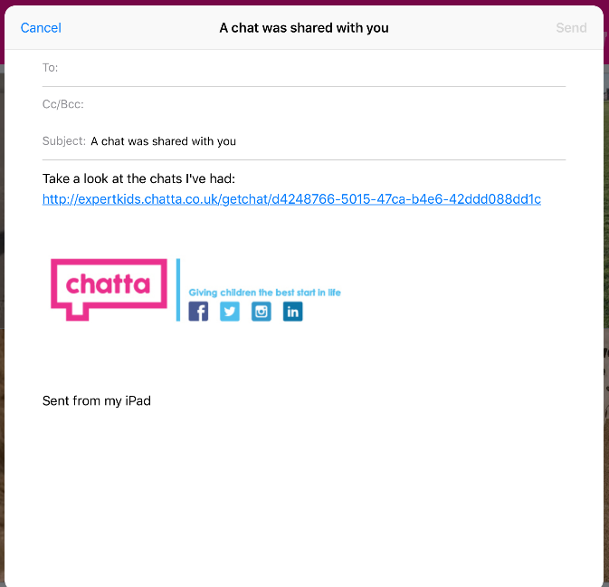

Examples of Chat’s in School

Signs of Spring 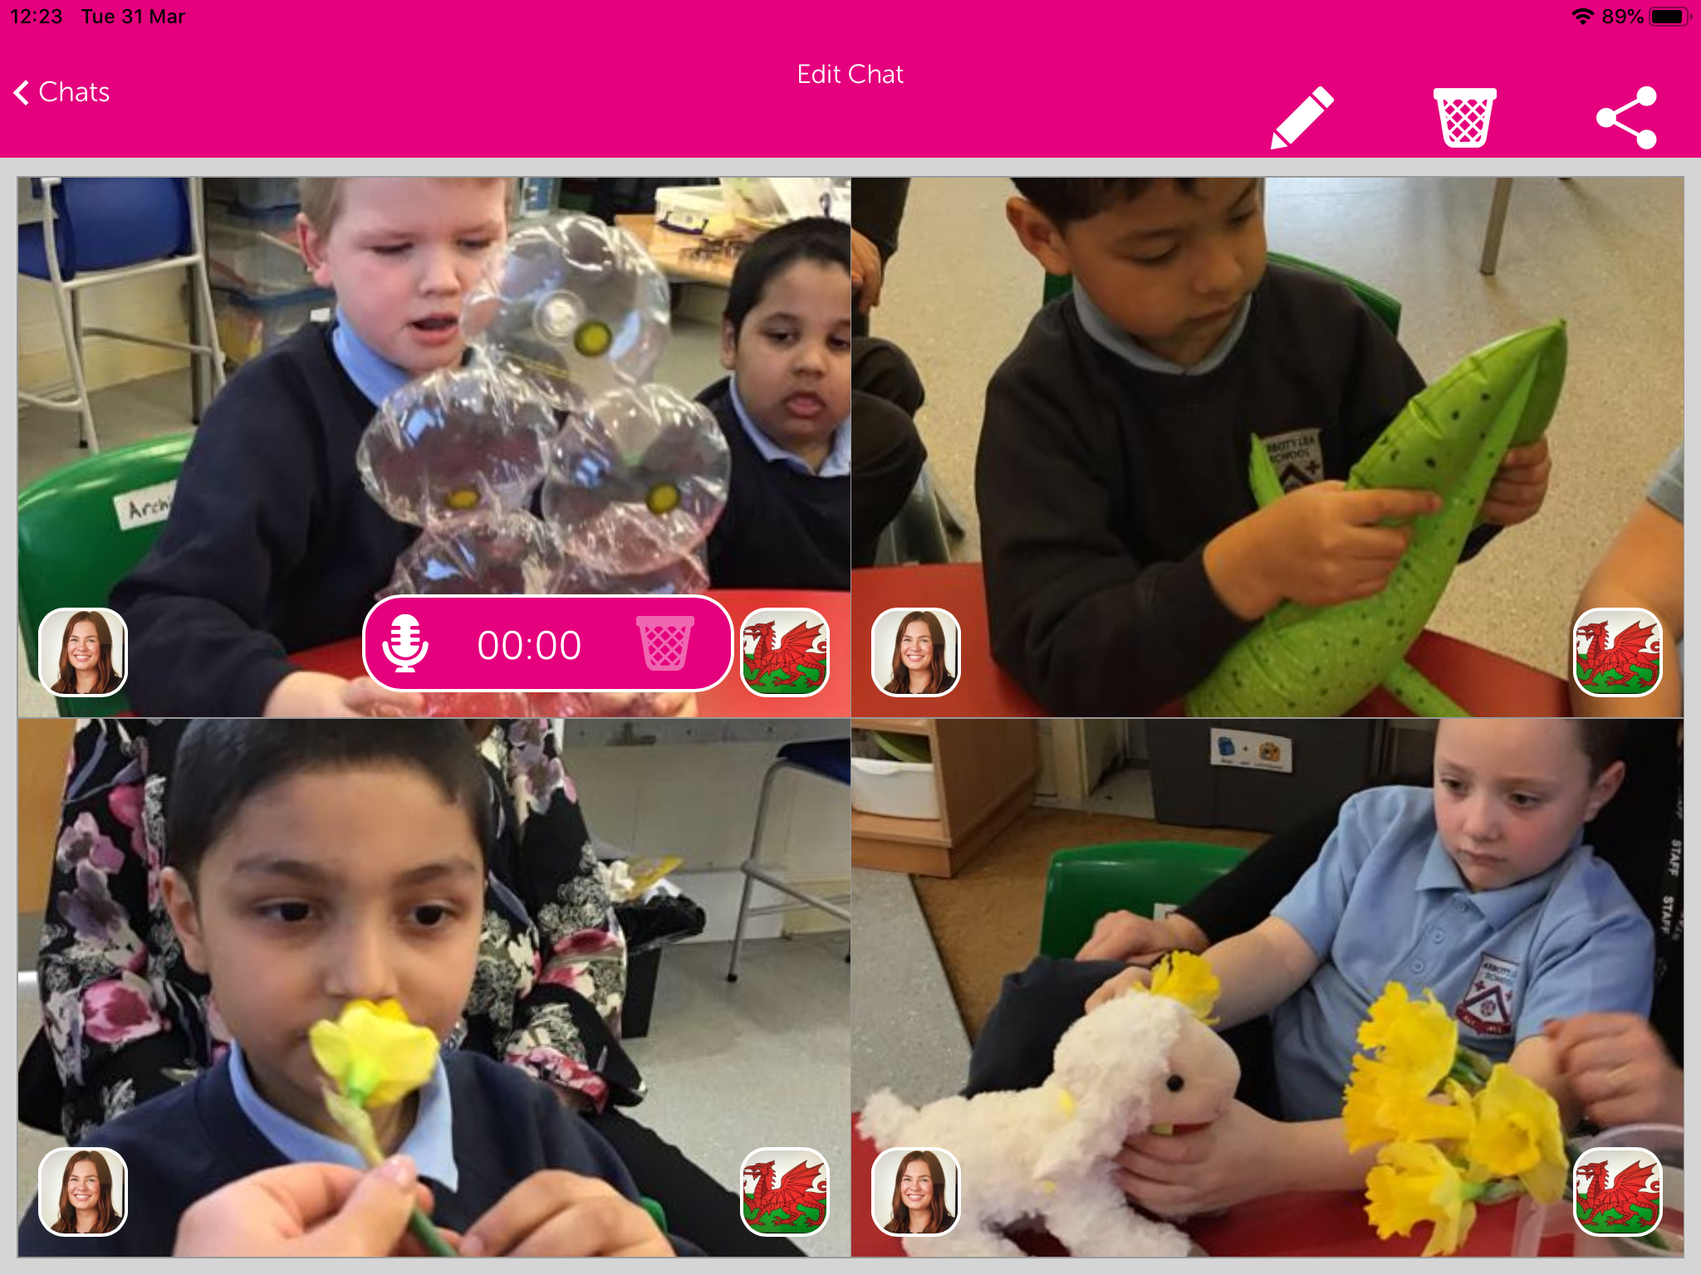
Sequencing – how to make rice crispy cakes 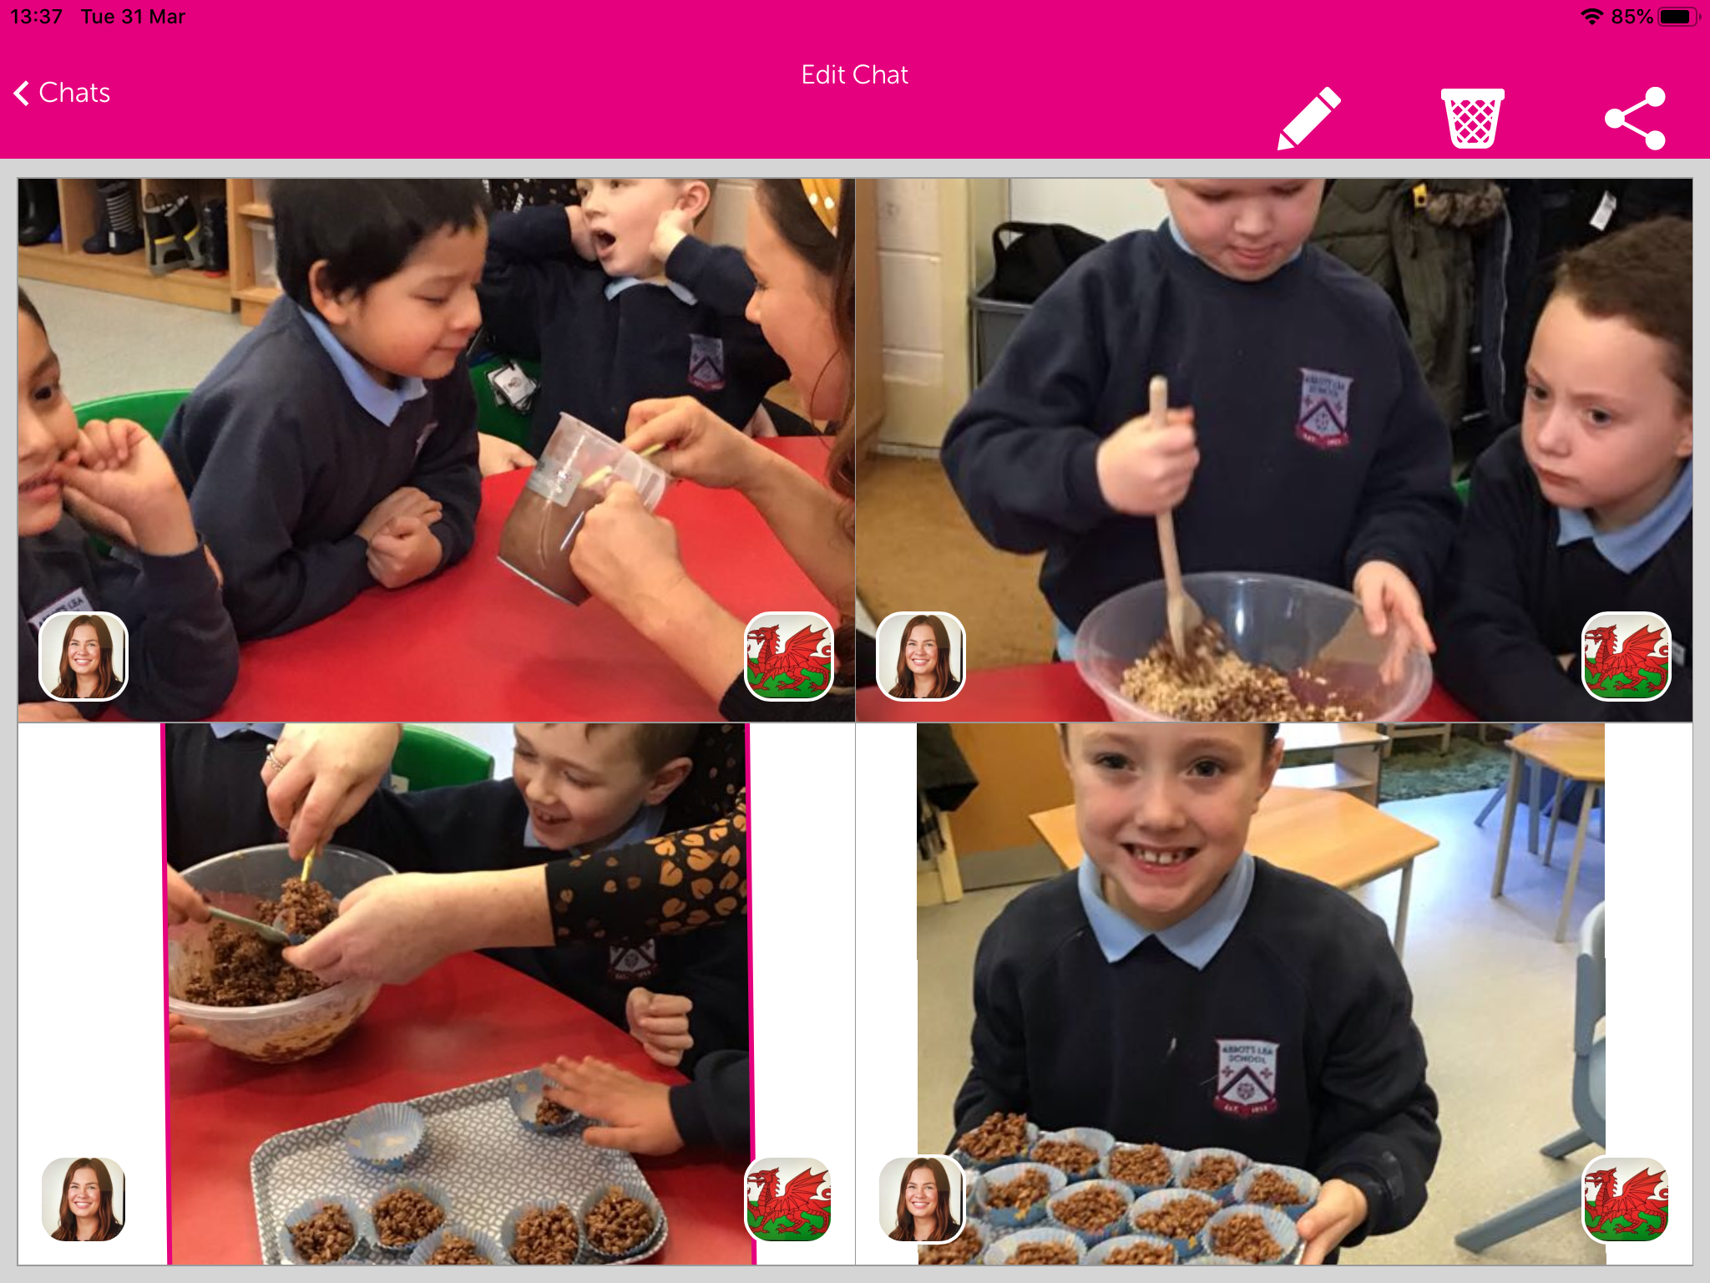
Exploring clues to a new story – Handa’s Surprise
Researching what the Vikings wore
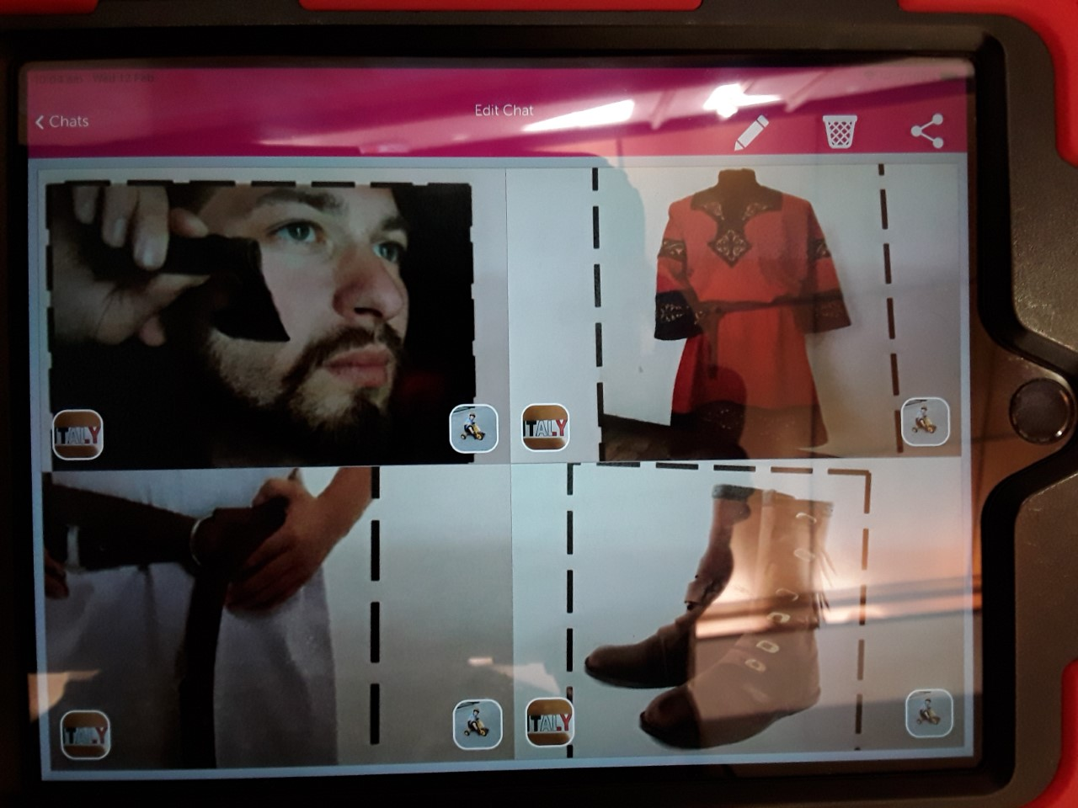
Learning about musical instruments – naming and how we play them
Recounting our trip to Chester Zoo
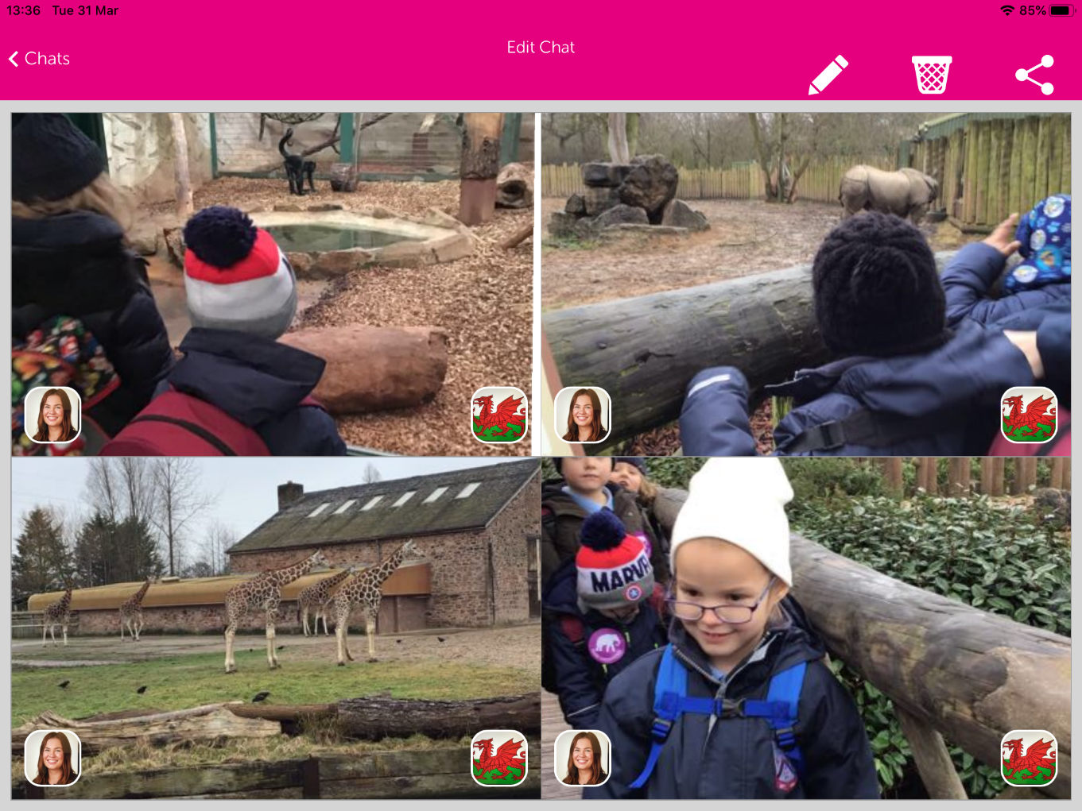
Learning about verbs at the park
