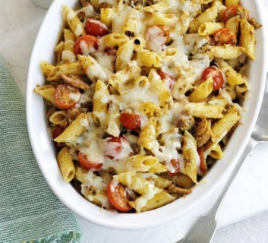
Cheesy Tuna Pesto Pasta
PREP: 10 MINS
COOK: 15 MINS
EASY SERVES 4

Ingredients
400g dried pasta
200g can yellowfin tuna in olive oil
190g jar basil pesto (or try a different flavour such as spinach, tomato or aubergine pesto)
100g cheddar, grated
250g punnet cherry tomato, halved

Method
Boil the pasta carefully in a saucepan, following the instructions on the packet.
Meanwhile, tip the tuna and its oil into a large bowl with the pesto. Mash together with a spoon or fork.
Stir in a third of the cheese and all of the tomatoes.
Heat the grill to high.
When the pasta is cooked, drain and stir in the pesto, tuna, cheese and tomato mix.
Tip into a shallow baking dish and scatter with the remaining cheese.
Place the dish under the grill for 3-4 mins until the cheese is just melted. (Use oven gloves or a tea towel to remove as the dish will be hot)
Try serving with a green salad and garlic bread.

