Citizenship activities
Activity 1: For a fun activity to do with your family members or the people you live with ask them the series of questions on the activity 1 cards. You could do this as a 1 to 1 activity or do it with everyone you live with together.
Activity 2: We are thinking about the theme of our heroes this term. During the current coronavirus pandemic it is widely recognised how heroic NHS staff and other key workers have been. They have both supported those with the virus and helped keep the country running smoothly. Included are a number of design of posters that you can colour in to celebrate these heroes or perhaps you could come up with your own NHS/keyworker hero posters/designs. You could do any of the following
- Design a poster to put in your window.
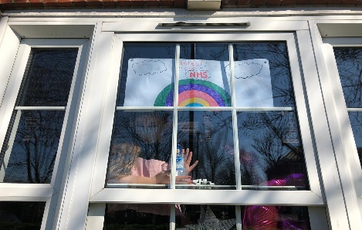

- Make a banner

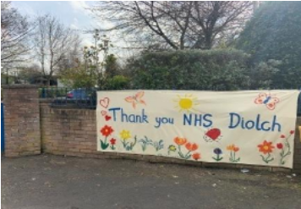

- Draw a chalk design on the pavement outside.

