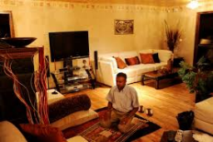
Debate: You do not need to go to a place of worship to be a Muslim.

Complete the boxes with information you learned on the PowerPoint. Write down your opinion at the end.

Disagree
Agree

Do you agree or disagree? Explain why.

Sentences Starters:

I agree with this statement because
I disagree with this statement because

