Science

Activity- Materials

What you will need;
Five different objects from around your house
Post it notes/ pieces of paper
Pencil/ pen

Activity;

- Go on a hunt around your house and select five different objects.
- Once you have your objects discuss with somebody in your house about the different materials you think it is made from.
- If you have post it notes or pieces of paper write down the different materials the object has.
- Challenge: Can you name the different properties of the material i.e. is it flexible.
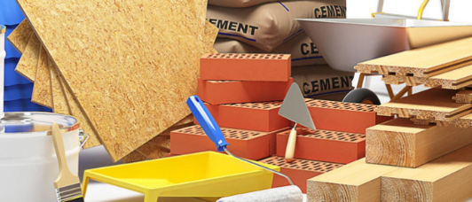

Don’t forget to send a picture to your teacher!

