Science

Activity- Draw around your hero

What you will need;
A hero
Chalk
A floor outside or a large piece of paper

Activity;
- Ask your hero to like down on to the ground/ on your piece of paper
- Use your chalk and carefully draw around your hero
- Ask you hero to stand back up
- Work with your hero and label the different parts of their body
- Challenge: Can you label some of the organs inside of the body? How many can you think of?
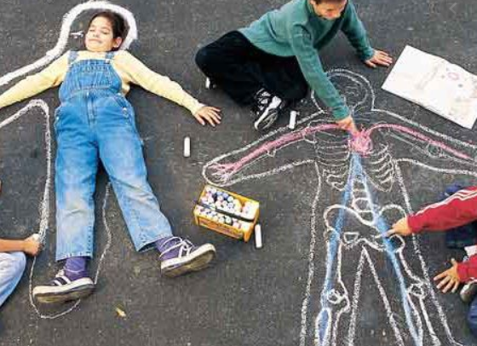

Don’t forget to send a picture to your teacher!

