EYFS/KS1 Home Learning
Letter Formation - Outdoors Activity 2
Things you will need  - Pot / Bucket of Water  - Paintbrush or Roller – the bigger the better!  - Chalk  - Your garden / outdoor area at home  All equipment can be swapped for something else that is similar based on what you have at home. | 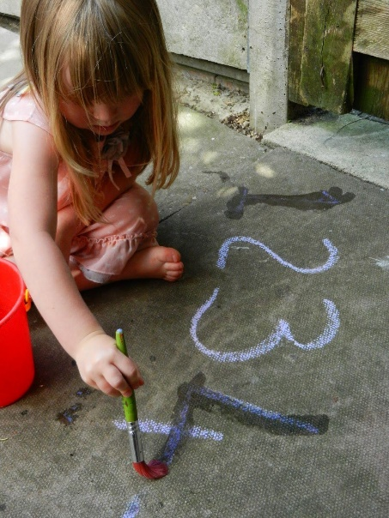
Activity

This activity is to encourage children to engage with their letter formation skills in a fun way, using large arm and wrist motions to build on gross motor skills. Please encourage the pupils to collect their own equipment where possible. Do as little or as many steps as you like!

- Use the chalk to draw large letters on your floor or wall. This could be on a patio, decking, fencing panels or brick walls.

You can use all of our different phonics phases or a few letters as you like!

s a t p i n

m d j o c k

- Children can then use their paint brush or roller with water to trace over your chalk letters!
- Can they write their name with the paintbrush? The bigger the better!
- Practise saying the sounds – can you spot something in your garden / outdoor area beginning with that sound?!
- Make marks and shapes with your paint brush. The bigger the better!

