EYFS/KS1 Home Learning
Number Matching - Activity 1
Things you will need  - Pegs  - Lolly sticks, paper or cardboard  - Coloured Pens  All equipment can be swapped for something else that is similar based on what you have at home. | 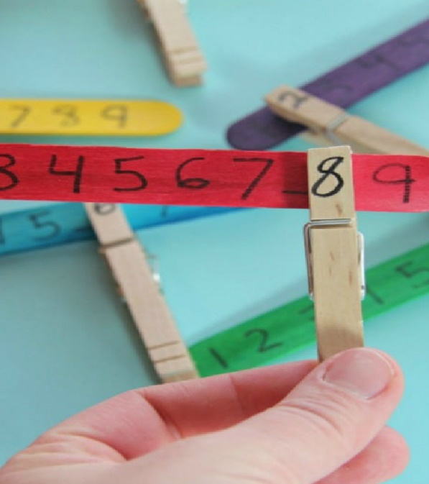
Activity

This activity is to help the children build confidence and practice their number recognition. Please encourage the pupils to collect their own equipment where possible.

- Take a lolly stick and make it as colourful as you like!
- Write numbers 0 to 10 on your lolly stick. You can make extra ones with higher numbers on if you like.
- Take you pegs and on each one write a corresponding number, again, from 0 to 10.
- Use the pegs to match the numbers on the lolly stick. How many can you find?! Can you find how old you are?
- Optional Activity: You can make a lolly stick with missing numbers. Can you find the correct peg with the missing number?!

