KS2 Home Learning Project - English
Week 1: Our Home Heroes
This week we will be completing activities around ‘Our Home Heroes’. This could be mums, dads, grandparents, sisters or anyone else who is looking after us right now. They are working so hard to keep you happy and safe. They are our Heroes!
Activity 1 | Activity 2
Draw a picture of a member of your family who is helping you at home.  Can you write a sentence or some words about this person and why they are your ‘home hero’  Note to parents: The writing aspect of this may need support; this can be written by you and copied from a piece of paper or written in a light coloured pen or pencil to be ‘overwritten’. | Create a thank you card for your home hero to say “thank you” for all that they are doing to keep you safe and happy.  Note to parents: This is a great activity for the children to make their own decisions about their creative process and to develop independence in terms of what equipment they need. You can encourage this by asking them what they might need rather than gathering it for them.  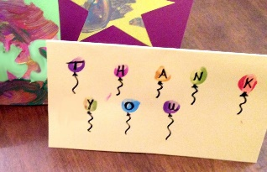
Activity 3 | Activity 4
Write a letter to your home heroes, writing about all the things they do for you to help. Remember to say to thank you.  Note to parents: This activity will focus on the children using capital letters and full stops throughout their letter, they may require support when writing the sentences. Either through copying sentences you have written on a piece of paper or written in a light coloured pen or pencil to be ‘overwritten’ | Read your favourite book or story to your home hero to say thank you for helping you every day.  Note to parents: This is a lovely activity to promote reading and encourage the children to read aloud with someone.  