Fossil Hunters
LO: To be able to identify fossilised remains and understand the process of fossilisation
Task –
- Draw a picture
- Add a fact
Use your fossil guide to help you discover each of the fossils at the stations!!!

Station 1
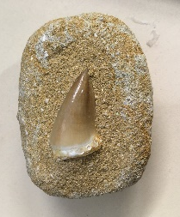 | Dino Tooth

Station 2
Bivalve Shell

Station 3
Trilobite

Station 4
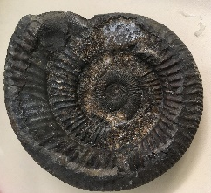 | Amonite

Station 5
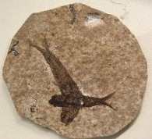 | Fossilised Fish
Station 6
Orthocone Nautiloid

Station 7
Shark took

Station 8
Opel Shell Fossil

Station 9
Fossilised Coral

Station 10
Crinoid

Station 11
Trace dino track

