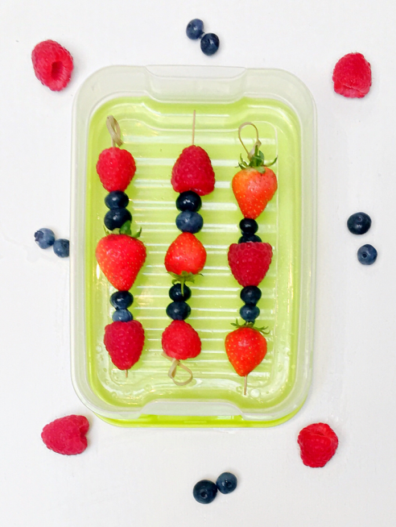
Fresh Berry Skewers

Here is a really simple recipe for you to try.
Ingredients
1. Small fruit skewers (can use cocktail sticks)
2. A selection of berries (blueberries, raspberries, strawberries)
3. Natural yoghurt dip.
Method
1. Wash and place a selection of berries in different pots.
2. Thread the berries onto the skewers (be careful not to hurt your fingers!)
3. Eat them as they are or dipped into natural yoghurt.

