Making an Ammonite Fossil Help Sheet

LO: To be able to identify fossilised remains and understand the process of fossilisation

Task – To follow the instructions below to make my own ammonite fossil mould.

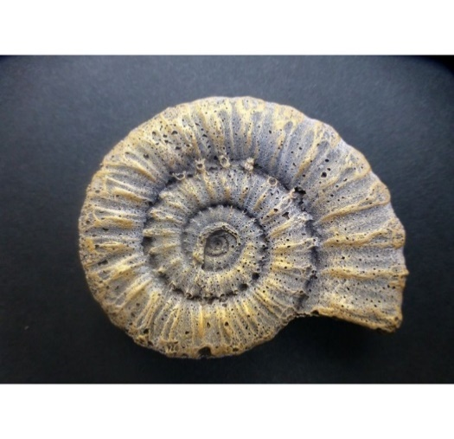

**Step Three**

Once you have mixed the plaster of paris to the correct consistency, add it to the mould. Add a small amount each time to ensure the mould if full and all detail shows when it sets.

**Step Two**

Mix two table spoons of plaster of paris in your mixing cup with one tea spoon of water. Keep adding water until you get a thick, gooey consistency.

**Step Four**

Leave the mould to set for around 7-10 minutes. Once the mould is set and the plaster feels hard, push the ammonite mould out of the shell onto a paper plate and write your name next to it.

**Step One**

Put on your protective gloves and gather the following equipment:

* Ammonite mould
* Mixing cup
* Spoon
* Plaster of paris
* Water