KS2 Home Learning Project
Week 1: Our Home Heroes
This week we will be completing activities around ‘Our Home Heroes’. This could be mums, dads, grandparents, sisters or anyone else who is looking after us right now. They are working so hard to keep you happy and safe. They are our Heroes!
Activity 1 | Activity 2
Look at photographs of you and your home hero together throughout your life. Can you ask questions like ‘who’ ‘where’ and ‘when’ as you are looking at them?  Extension – Ask your home hero when the pictures were taken. Build a timeline of special events that have taken place during the time you have spent with your home hero. Think about including days out, holidays, family birthdays and the birth of brothers, sisters or cousins.  Note to parents: This is a history activity based on developing the concept of history and the passage of time. You could encourage the children to ask you questions about where the photograph was taken or who is in the image. To extend the activity, you could support the children in ordering the pictures in chronological order. | Using an IPad, laptop or computer create a virtual timeline of your home hero, you might choose to use Microsoft PowerPoint for this. Can you draw pictures on the computer to represent different times in your home hero’s life?  Extension – Write a short sentence explaining what is happening in each picture.  Note to parents: This is a history activity based on developing the concept of history and the passage of time. If children do not have access to technology, they can complete the activity using paper, and putting pictures next to one another to create a timeline. Students can then write a brief sentence and attach it to each picture.  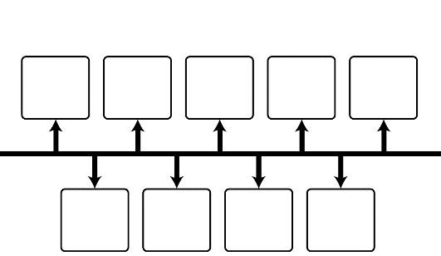
Activity 3 | Activity 4
Create a fact file of your home hero. You can include information such as their name, where and when they were born, how old they are, what jobs they have had as well as any other interesting facts.  Extension – Attempt to draw a portrait of your home hero and attach it to your fact file.  Note to parents: This is a history activity based on creating a fact file of their home hero. Encourage students to ask you questions about your life so they can compile the information. | Compare the life of your home hero to your own life. Write down similarities and differences between you and your hero, this might include your birthday, how old you are, place of birth as well as interesting facts.  Extension – Put the similarities and differences into a Venn diagram, writing things both people have in common in the middle.  Note to parents: This is a history activity based on comparing the lives of their home hero and themselves. Students may find it easier to split a piece of paper into two and write information about both people, they can then use a highlighter or felt tip to underline things that are similar and things that are different.

