EYFS/KS1 Home Learning
Make a celebration bunting for your Home Heroes
Activity 2
Things you will need  - Cardboard/ cereal box/ paper  - Scissors  - Coloured pens or pencils  All equipment can be swapped for something else that is similar based on what you have at home. | 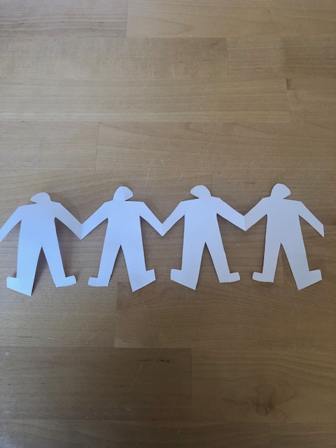  <INSERT PHOTO HERE>
Activity

Your Home Heroes are working hard to keep you safe and happy. Show them some love and gratitude with this simple bunting activity.
This activity is to practice fine motor skills and grip. It encourages children to be creative and use materials to celebrate their Home Heroes. Please encourage the pupils to collect their own equipment where possible.
1. Fold your piece of paper twice (or as many times as needed depending on how many Home Heroes live in your house)
2. Draw a simple outline of a person. Make sure that one of the hands touches the folded side of the paper.
3. Cut around your outline of the person
4. Open up your person shape and you will have a string of Home Heroes holding hands. It should look a little like bunting!
5. Colour each Home Hero in their favourite colour and stick up in your house or window to show your support for your heroes.

