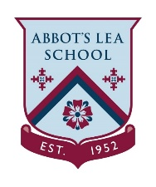

EYFS/KS1 Home Learning
Make a Hero mask for your Home Heroes
Activity 1
Things you will need  - Cardboard/ cereal box/ coloured paper  - String/elastic/ ribbon  - Scissors  - Coloured pens or pencils  All equipment can be swapped for something else that is similar based on what you have at home. | 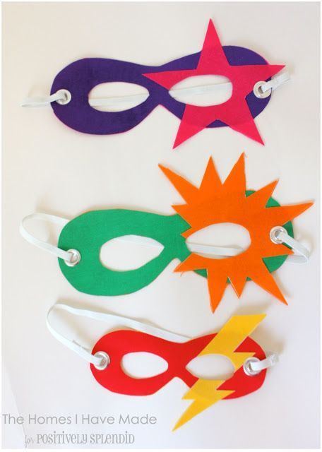  <INSERT PHOTO HERE>
Activity
All good superheroes need a cool mask and that goes for our Home Heroes too!
This activity is to practice fine motor skills and grip. It encourages children to be creative and use materials to celebrate their Home Heroes. Please encourage the pupils to collect their own equipment where possible.
1. Draw your Hero mask onto cardboard or coloured paper
2. Make a hole either side of the mask and attach your elastic. String or ribbon could also be used. Make sure to measure your Heroes head to check their mask fits!
3. You can now decorate your Home Heroes mask with shapes or their favourite colours/ patterns. Get creative and use anything you have around the house!
4. Put on your Home Heroes mask and have fun together as a family. Don’t forget to send us your pictures, we would love to help you celebrate your Home Heroes!

