Homemade Play Dough
What you will need:
- 1 cup flour
- ½ salt
- ½ cup water
- Bowl
- Spoon
- 4-5 drops of food colouring or water based paint (optional)
What to do:
- In your bowl mix your 1 cup of flour, ½ cup of salt and gradually add your ½ cup of water.
- Stir the mixture, if it becomes too dry add a little bit more water.
- Begin to knead the dough with your hands, if it becomes too sticky add a little bit more flour.
- Once your dough is the right consistency you can add colour using food colours or water based paint.
- To make different coloured playdough, simply split the dough into sections before adding the colour (make sure you wash your hands after each colour).
- You can store your playdough in a bag and in the fridge to make it last longer.
- Have fun!!!
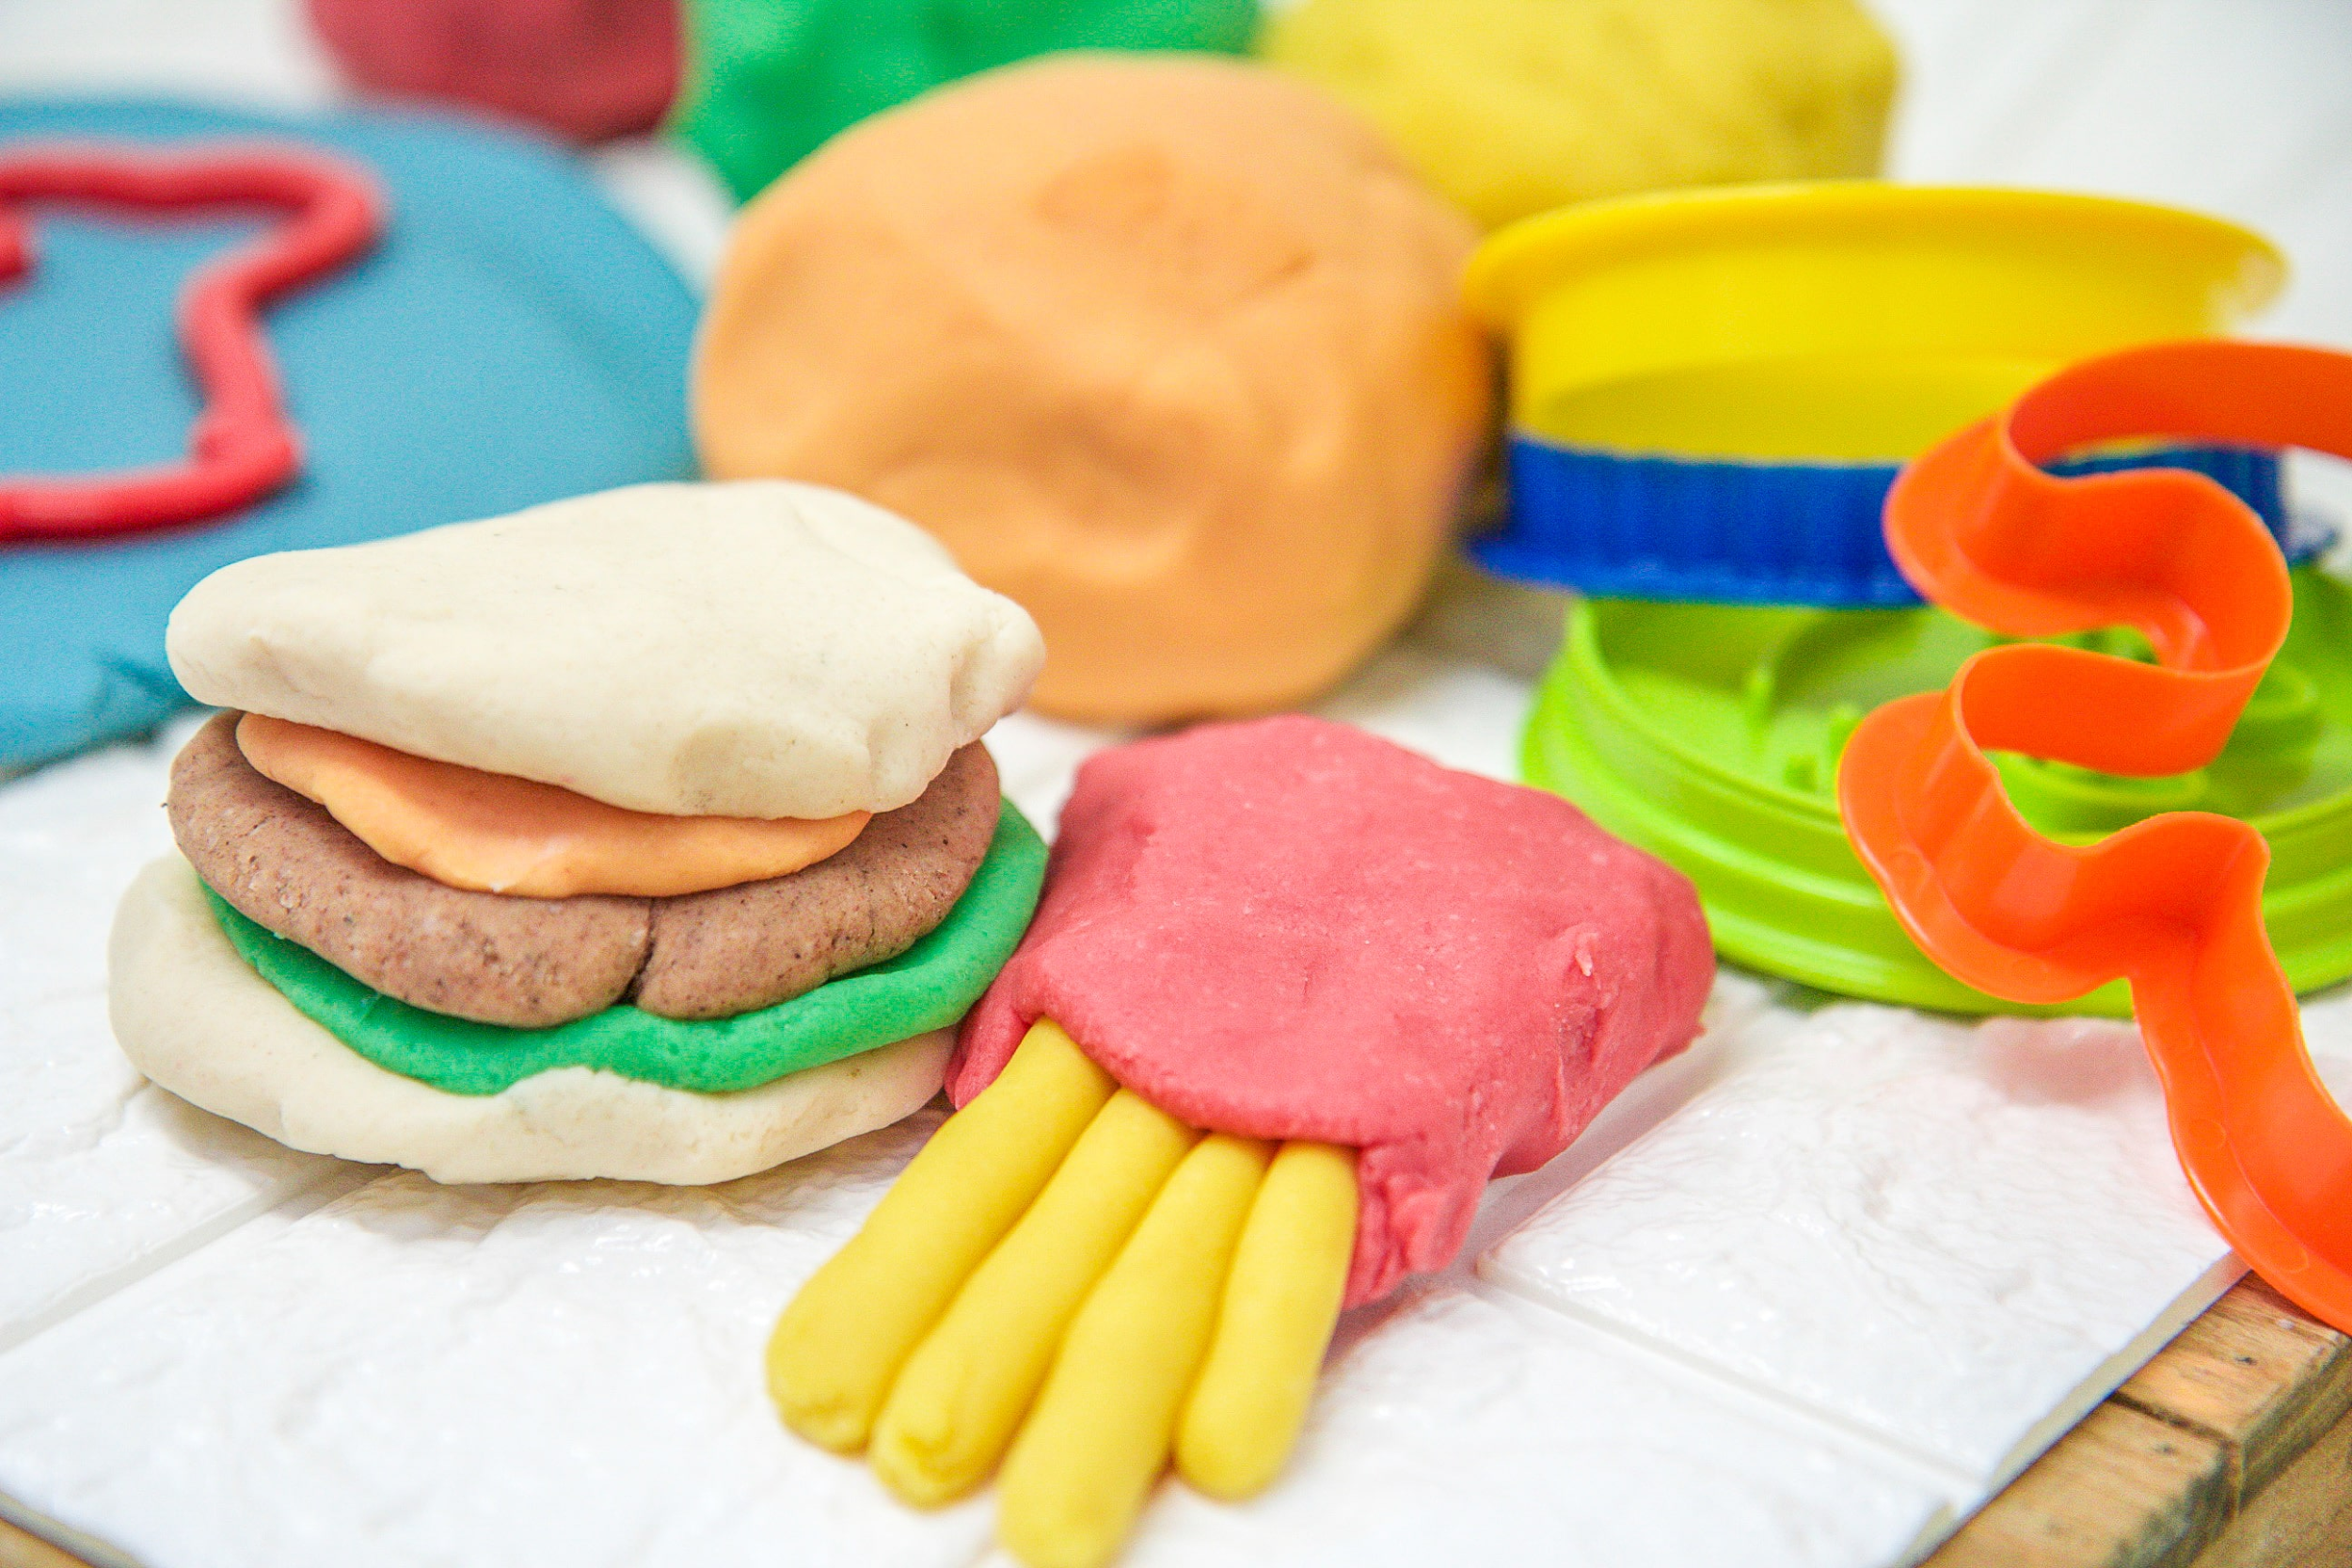
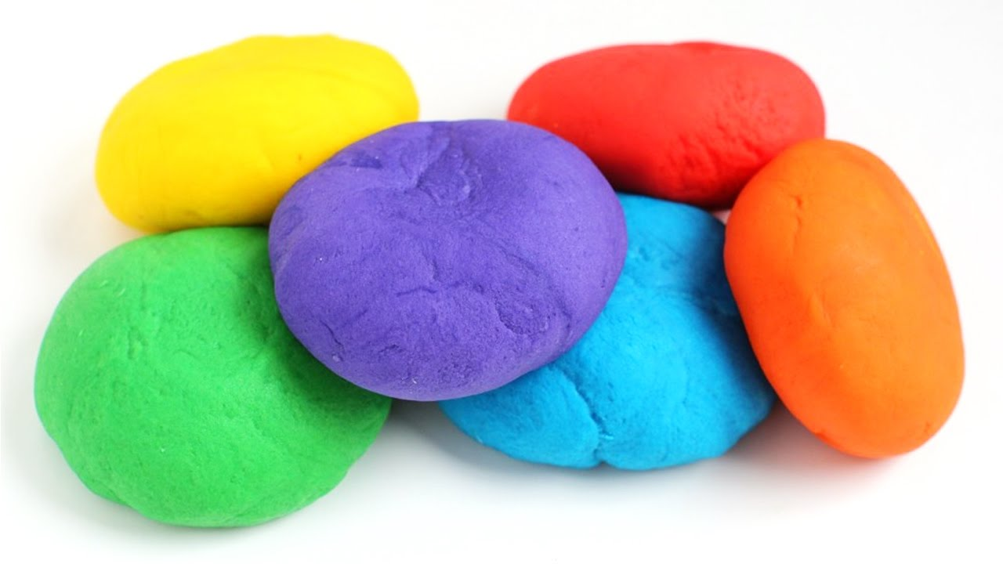

Video to demonstrate - https://www.youtube.com/watch?v=oAIAm6BF0fs

