How to colour in with paint.

Open paint.

Click on the blue home button top left.

Choose open, open the black and white picture you want to use, in this case Bluey.

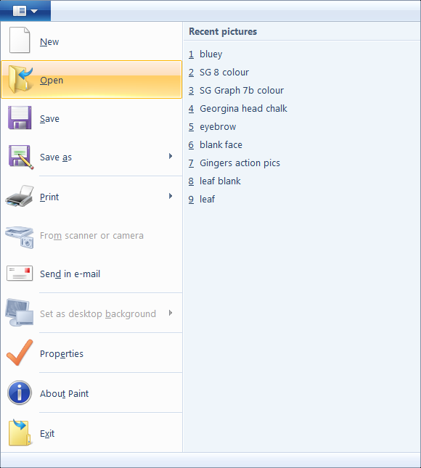

If the picture is too big, choose view zoom out, if it’s too small choose view zoom in.

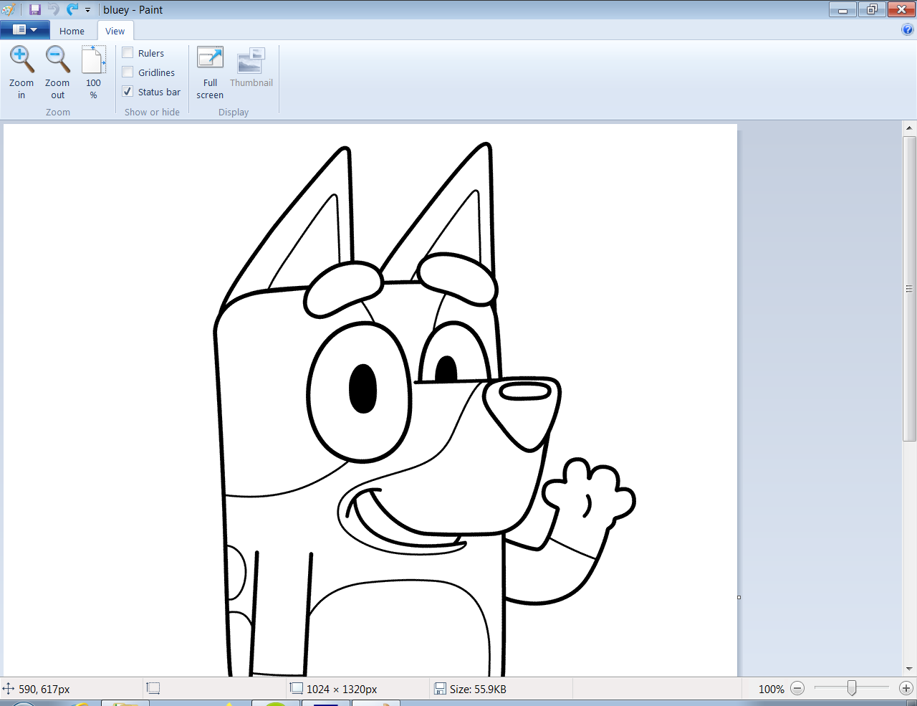

Click home, then choose the fill bucket then choose the colour you want to use.

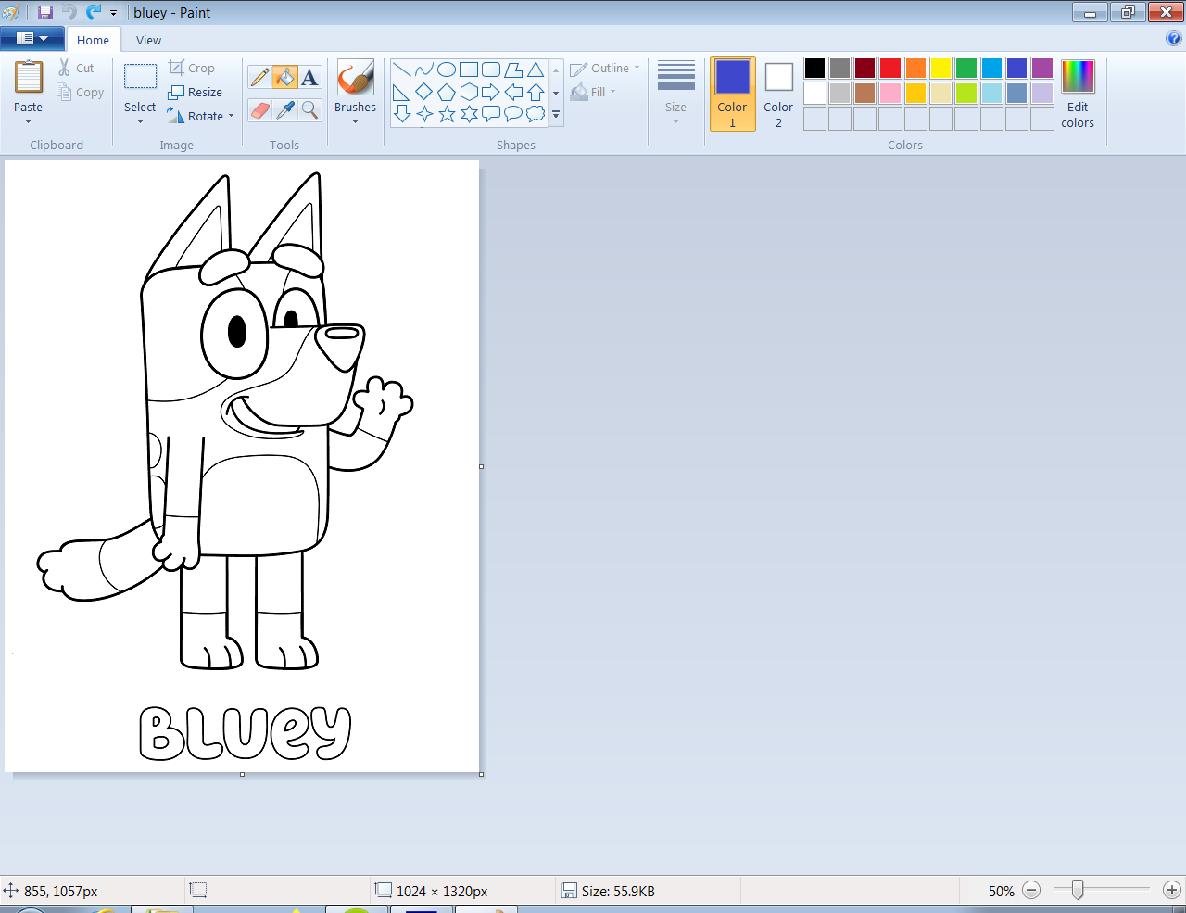

Hover the cursor (Should look like a bucket) over the part you want to fill, then left click.

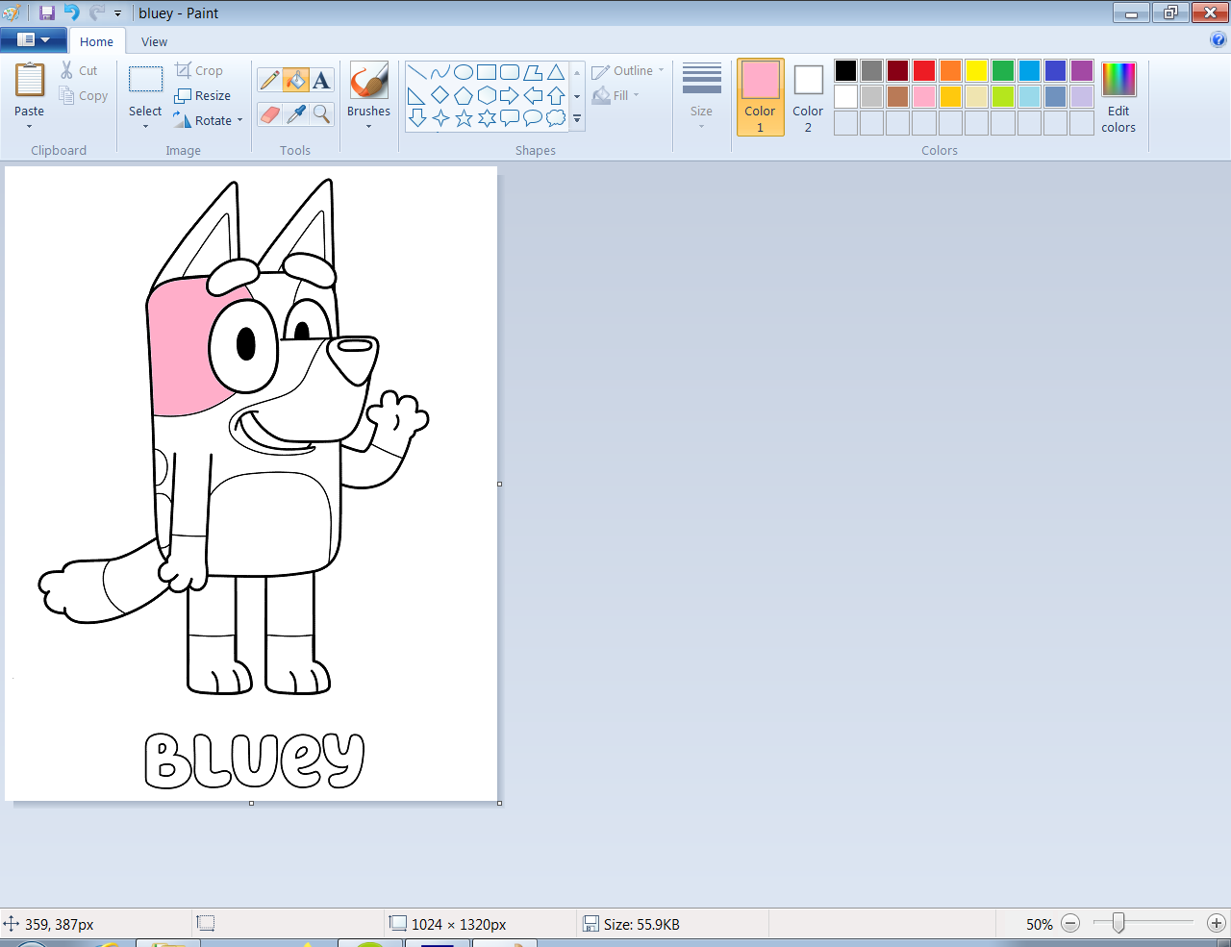

Then carry on filling the other spaces.



