How to make cloud dough

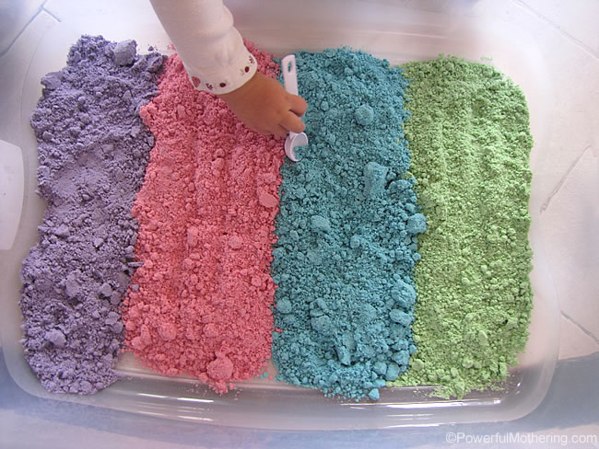

We made our cloud dough with vegetable oil to make it edible and ultimately taste safe. Edible does not mean eat it by the spoon full! It means that if your child were to take a taste it would be perfectly fine.
To make cloud dough mix in the 1:8 ratio. That is 1 cup of oil to 8 cups of flour.

Ingredients
- 2 cups All purpose flour
- 1/4 cup Vegetable oil canola / olive oil
- 5-10 drops Oil based food colouring

Instructions
- Make at least 4 colours. Use your kitchen measuring cups and don’t guesstimate else your cloud dough recipe will be too wet.
- Premix colouring in the oil before adding it to the flour.
- Mix your ingredients in a ziplock bag. Knead and shake around until mixed as much as possible.
- Before you play you will have to get your hands into the mix to pinch the flour to distribute the remaining oils and colouring. At this point, it should be mixed well enough that your hands will not stain.
- Empty out into a sensory tub for playing.
- If you do this activity indoors a large bed sheet or shower curtain is recommended for under the sensory tub to catch little messes.

For video instructions please follow the link below :
https://www.youtube.com/watch?v=1Rkxx1TC-E4

