Ice cube sailboats
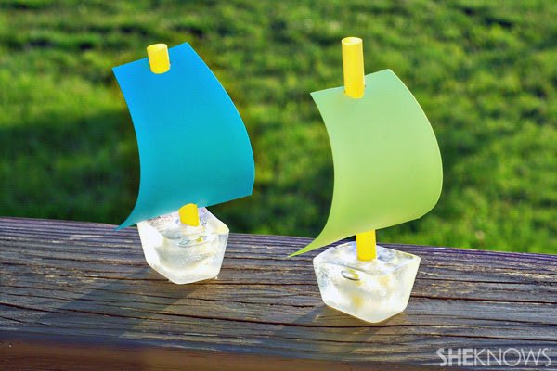

What you’ll need:
- ice cube tray
- water
- straws
- scissors
- construction paper
- hole punch

What you’ll do:
- Fill the ice cube tray with water and place it in the freezer.
- Pull the ice cube tray out of the freezer before it has had the chance to freeze completely.
- Cut straws in half and place the straw in the center of the ice cube.
Be sure that the straw is as centered as possible, or the boat will be off balance.
- Place the tray back in the freezer to harden completely.
- Cut sails for the boats out of construction paper.
Use the hole punch to punch a hole at the top and bottom of the sail.
- Pop the ice cubes out of the tray. Slide the construction paper sail on to the straw, then place the boat in water for an ice cube sail boat race!

Image credit: Amy Vowles

