KS2 Home Learning
Emotions Activity 1
Things you will need  - A tablet or phone.  - Breathe, Think, Do with Sesame App.  - An adult to sit with. | 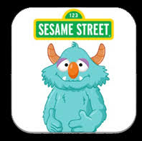
Activity
With your adult see if you can help the monster through some tricky situations and difficult emotions!
https://apps.apple.com/gb/app/breathe-think-do-with-sesame/id721853597

https://play.google.com/store/apps/details?id=air.com.sesameworkshop.ResilienceThinkBreathDo&hl=en_GB

