KS2 Home Learning
Emotions Activity 2
Things you will need  - A computer and printer or colouring pencils and paper  - Scissors  - A keyring or piece of string.  - An adult to join in. | 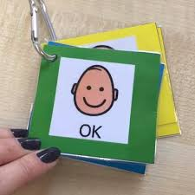
Activity
- With your adult talk about the different difficult emotions you might feel and some easy activities you could do to help to get back in the green zone.
- Use the template below or make your own double sided cards.
- Cut them out carefully and tie them together or put them on a key ring.
- See if you can help your adult make their own key ring too!

Don’t forget to change the words so it is personal to you!
