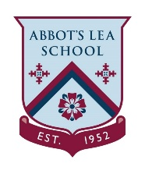
KS2 Home Learning Project - English
Week 3: Our Medical Heroes
This week we will be completing activities around ‘Our Medical Heroes’. This could be doctors, nurses, paramedic, surgeon and ambulance drivers. They are working so hard to keep you safe. They are our Heroes!
Activity 1 | Activity 2
Complete a comparison between Victorian and modern day hospitals. Is there anything the same or different?  Note to parents: Research and complete a comparison of Victorian and modern day hospitals. | Read the information about Florence Nightingale then complete the comprehension questions.  Note to parents: Help your child read the information and complete the differentitated comprehension questions.
Activity 3 | Activity 4
Find the key words about Florence Nightingale in the word search.  Note to parents: Print out the word search and encourage your child to find the key words. | Complete role-play scenarios and fill in an incident form.  Note to parents: Join in with the role-play and support your child to fill in the incident form.

