KS2 Home Learning Project - English
Week 3: Our Great Outdoors - Minibeasts
This week we will be completing activities around ‘Our Great Outdoors’ thinking about minibeasts.
Activity 1 | Activity 2
Read the information sheet about minibeasts. Complete the comprehension questions about what you have read  Note to parents: There are 3 levels of reading and comprehension. Choose the most suitable for your child’s ability. | What am I ?  Read the clues on the powerpoint and guess what minibeast is being described.  Note to parents: Open the powerpoint and support your child with reading the clues about a minibeast  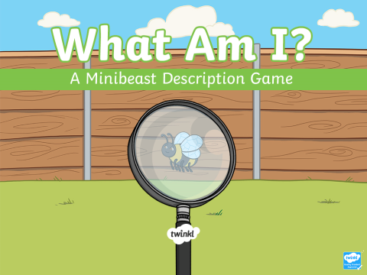
Activity 3 | Activity 4
Write an acrostic poem about your favourite minibeast.  Note to parents: To help your child, write a list of words you could use to describe their favourite minibeast. | Find the key words about minibeasts in the word search.  Note to parents: Print out the word search and encourage your child to find the key words.

